THE TOWN OF CHASE CITY

COMPREHENSIVE PLAN

THE FUTURE 2032

“PLAN TODAY FOR TOMORROW”

COMPREHENSIVE PLAN

TOWN OF CHASE CITY
VIRGINIA

Prepared by
Chase City Planning Commission

Adopted by
Chase City Town Council
On September 12, 2012

OFFICERS OF THE TOWN
OF CHASE CITY, VA.

TOWN COUNCIIL
J. Eddie Bratton, Mayor
Rickey G. Reese, Town Manager
Lisa A. Gillispie, Vice-Mayor
Winthy Hatcher, Jr.
James E. Bohannon
Charles Willis
Brenda Hatcher
Marshall Whitaker

PLANNING COMMISSION
M.J. Colgate, Jr., Chairman
Winthy Hatcher, Jr.
C.L. Garner, Jr.
Cynthia Gordon
Glenn Wood

ACKNOWLEDGMENTS
The members of the Planning Commission grateful acknowledge the efforts of the following persons or entities that assisted in the preparation of this document.

Responsibility for the interpretation and analysis of data and the recommendations of the final draft, as it was delivered to the Town Council, rests solely with the Chase City Planning Commission
Mr. Rickey G. Reese, Town Manager
Town of Chase City
Employees of the Town of Chase City
Mr. William E. Moore, Jr. Consultant
Mr. Andy Wells, Staff
Southside District Planning Commission

TABLE OF CONTENTS
PLANNING PRINCIPLES & VALUES ………………………………………….8
Background
Authority to Plan
Scope & Purpose
Using the Comprehensive Plan
Principles & values
COMMUNITY PROFILE ……………………………………………………………16
Location
History
Town Government
POPULATION ……………………………………………………………………………19
Background
Population Data & Trends
Significance for Planning
HOUSING …………………………………………………………………………………..28
Background
Inventory & Analysis

EMPLOYMENT & COMMERCE …………………………………………………….33
Background
Employment
Economic Development

PUBLIC SERVICES ………………………………………………………………………….46
Background
Public Utilities
Electricity & Natural Gas
Solid Waste Collection & Recycling
Police & Emergency Services
Health Facilities
Educational Facilities
Library Services
Public Recreation
Other Public Services & Facilities
TRANSPORTATION ………………………………………………………………………….85
Background
Inventory & Analysis
COMMUNITY ATTITUDES ………………………………………………………………..55
Determining Community Attitudes
Citizens Survey
Analysis of Results
Preservation of Small Town Atmosphere
Environmental Preservation
LAND USE …………………………………………………………………………………………73
Inventory and Analysis
Goals & Objectives
FUTURE LAND USE PLAN …………………………………………………………………..76
Background
General Land Use Patterns
Growth Policy Statement
OBJECTIVES & STRATEGIES ………………………………………………………………..82
THE COMPRESHENSIVE PLAN
The Strategy, Assumptions, Implementation ……………………………92
APPENDICES ……………………………………………………………………………………101
Boundary Adjustment Area
Town Map
Water & Sewer Maps
Town Zoning Map

PLANNING PRINCIPLES & VALUES
______________________________________________
BACKGROUND

The Chase City Comprehensive Plan was first adopted in 1992 and was used by the Town officials to guide growth and development. In 1998, as a result of changing conditions and a need for more thorough analysis of the Town needs, the Chase City Town Council initiated an update which is the current Comprehensive Plan.
The Virginia Code requires each political subdivision to review their plan for updating at least every five years, and more importantly, to take into consideration changes which affect the future of the Town, the Town Council has initiated a comprehensive update of the present plan.
The objective of the Comprehensive Plan is to create a framework within which to make decisions regarding the physical, social, economic, and environmental development of the community. These elements are interdependent and maintaining the balance between them is critical to a vibrant, healthy, and sustainable community.
The Comprehensive Plan should be viewed as comprehensive, general, action-oriented, and long range in nature.
Comprehensive: The Plan is comprehensive in that it looks at all geographical areas within the Town as defined by current Town boundaries as well as areas outside the Town that may be influenced by, or have influence on, the development of Chase City.
General: The Plan is “general” in that it establishes policies that anticipate the future through general guidelines. It does not contain specific details concerning every problem, issue, use, or location that will be addressed in coming years.
Action: The Plan is also oriented toward taking action by providing guidance to citizens and public officials on decisions of local governance.
Long-Range: The Plan is “long-range” in that it is based on a time frame beyond the present and anticipates future opportunities and challenges

Authority to Plan
Article 3 of Chapter 22 of Code of Virginia 15.2, 1950 (as amended) outlines requirements and objectives concerning comprehensive planning by local jurisdictions. Every local government is required by state law to adopt a comprehensive plan. The Planning Commission of the Town of Chase City is charged with preparing a comprehensive plan for the physical development of the Town for consideration and adoption by the Town Council.
State law requires the Planning Commission to review the plan every five years to evaluate the need to amend the plan; however, the Comprehensive Plan must be in agreement with the Zoning Ordinance and should be revised as often as necessary. The Commission is required to evaluate existing conditions and growth trends and determine probable requirements for future growth and land development.
SCOPE & PURPOSE
The purpose of the plan is to guide and accomplish a “coordinated, adjusted, and harmonious development which will, in accordance with present and probable future needs, and resources, best promote the health, safety, morals, order, convenience, prosperity, and general welfare of the inhabitants.” The Plan must consider such items as the characteristics of existing developments and use of land, natural resources and conditions, populations, employment and economic factors including future requirements, existing public facilities and utilities, housing needs, and other matters relating to the purposes of the comprehensive plan. The Plan also is required to examine and recommend methods for implementing plan goals, objectives, and recommendations.
State law requires that the Comprehensive Plan be general in nature, designating “the general or approximate location, character, and extent of each feature shown on the plan” and indicating “where existing lands or facilities are proposed” to be altered or changed in use. The law requires that long-range recommendations be formulated for the general development of the areas covered by the plan. The law further states that these recommendations may include, but are not limited to
- The designation of areas of various types of public and private development and use, such as different kinds of residential, business, industrial, agricultural, conservation, recreation, public service, floodplain and drainage, and other areas.
- The designation of a system of transportation facilities.
- The designation of a system for community service facilities such as parks, forests, schools, playgrounds, public buildings and institutions, hospitals, community centers, waterworks, sewage disposal and waste disposal areas, and the like.
- The designation of historical areas.
- An official map, a capital Improvements program, a subdivision ordinance, a zoning Ordinance, and a zoning district map.
The law requires that the plan “designate the general or approximate location, character and event of each feature shown on the plan” and that development and subdivision requests must be “substantially in accord with the adopted Comprehensive Plan.”
State law also provides for the study and inclusion of adjacent unincorporated territory within a municipal plan. In addition to meeting the legal requirements for community planning outlined in the Code of Virginia, major purposes of the comprehensive planning process include:
- Encouraging citizens to develop a collective vision for the future that promotes the interests of the entire community rather than those of individuals of special interest groups.
- Identifying, protecting and preserving important features of the built and natural environment that collectively defines the character of the community.
- Establishing guidelines and standards for new developments and redevelopment to facilitate the creation of a convenient, attractive, and harmonious community.
- Establishing policies and procedures for evaluating short-term actions within the context of long-range community goals and objectives.
- Creating a framework for providing an efficient and coordinated system of public services, facilities, and utilities to the community.
Planning is a dynamic process of formulating goals, objectives, and standards to guide community growth and development. Planning also is a means of identifying strategies and techniques for achieving goals and objectives. The Comprehensive Plan provides guidance in balancing the long-term best interest of the overall community with the rights of private property owners. The Comprehensive Plan can help prevent uncoordinated individual actions that may produce undesirable cumulative effects.
Using the Comprehensive Plan
__________________________________________________________
The Chase City Comprehensive Plan reflects the input and collective best judgment of Town residents, elected and appointed officials, and town staff. The Town Plan provides a framework for achieving long-term community goals, but it is also designed to be flexible enough to respond to changing conditions and unexpected events. The Plan should be reviewed by Town officials and citizens on a periodic basis to ensure that the policies it contains reflect the current needs of the community.
Once the Plan has been approved and adopted by the Town Council, it becomes the official public document used to guide decisions on future development. The Town Council and Planning Commission use the Plan to evaluate rezoning and subdivision requests, review development proposals, determine road and public facility locations, and to develop capital improvement programs and budget recommendations. All policy decisions considered by the Town Council should be evaluated within the context of the Plan.
The various policy maps contained in the Plan illustrate the goals, objectives, and policies of the Plan text. Maps and other graphics illustrate the approximate locations considered most desirable for public facilities.
The future land use map provides a guide for determining the desirable location for relationships between various activities such as residential, commercial, and industrial uses.
The Comprehensive Plan and policy maps are general in nature and are for community planning purposes only. In some instances individual parcels or lots may not be clearly delineated and consequently may not be properly represented within general land use categories. The Planning Commission and Town Council have the responsibility of interpreting the policies and standards contained in the plan to determine specific location decisions for land uses, public facilities, utilities and roadways. Analysis and recommendations prepared by Town staff and sometimes officials of state or federal agencies assist the Town Council in reaching decisions.
The Comprehensive Plan guides the Town Council and Planning Commission in establishing or modifying techniques used to implement planning goals and objectives. Zoning and subdivision regulations are methods typically used to carry out the policies of the Plan. These ordinances determine where various types of land uses may occur and establish standards for development. A Capital Improvements Program (CIP) is another tool used to implement the Town Plan. Since the CIP determines the location and timing of capital projects such as roads and utilities, it is an effect mechanism to guide the direction and rate of future growth.
No street or connection to an existing street, park or other public area, public building or public structure, public facility or public service corporation facility (other than a railroad facility), whether publicly or privately owned, shall be constructed, established or authorized until it’s location has been approved by the Planning Commission as being substantially in accordance with the Comprehensive Plan.
The governing body, by majority vote, may overrule the Planning Commission, except for certain exceptions that are noted in Article 3 of chapter 22 of Title 15.2 of the Code of Virginia.
Principles & Values
The Comprehensive Plan is founded on a series of “Planning Principles and Values”. These are statements of fundamental belief held by the Chase City Community that were identified through various public processes. These concepts form the foundation for the principles described in each of the elements of the Comprehensive Plan and serve as a guide to citizens and elected officials in evaluating and planning for the future. The Planning Principles and Values are not a divergence from the historical desires of the Community, but rather an update and refinement of these desires in the effort to address existing and future challenges.
The planning horizon extends 20 years to the year 2032 and beyond. Following a 20 year planning horizon, the Town will continue to look into the future with a long-term perspective towards Comprehensive planning and land use issues.
The Comprehensive Plan is broad in scope and focuses primarily on the town as defined by the current Town limits but, where appropriate, it addresses larger geographic areas. In cooperation with our neighbors, residents will consider the larger region that is visually and physically interconnected with the Town, including Mecklenburg County and surrounding area. Other issues that are addressed with the Comprehensive Plan but involve larger geographical areas include, but are not limited to; land use patterns surrounding the Town and issues affecting the Southside Region.

COMMUNITY PROFILE
SCOPE
The Plan presents recommendations for long-range goals for the general development of the Town of Chase City and its environs. It is based upon the background information that includes:
- An economic and population analysis of the Town of Chase City and Mecklenburg County
- An analysis of the quality and quantity of housing in the Town
- An analysis of existing land uses
- An analysis of natural and manmade growth determinants
- Adopted Town goals, objectives, and policies relating to growth and development.

LOCATION

The Town of Chase City is located in Mecklenburg County, less than five miles from the Meherrin River, which forms a natural boundary line for the neighboring County of Lunenburg. Other neighboring towns include Boydton, Clarksville, and South Hill located 9 miles, 15 miles, and 22 miles east, respectively. Richmond is 95 miles northeast and the Port of Norfolk is 115 miles to the east.

Chase City was incorporated in 1873 encompassing a land area of 2.06 square miles. Although it is located in the heart of the tobacco belt, the growth of tobacco has diminished in recent years due to the elimination of the support system by the U.S. Department of Agriculture. This has resulted in an increase in cattle farming and the raising of soybeans.

HISTORY
The village that was later to become Chase City evolved from a settlement at the junction of several important roads in the eighteenth century. The Town first began as Raine’s Tavern, then Christiansville, which was in existence by at least 1800 when it was first known to have been a post office. By 1820, Christiansville, had acquired the nickname, “the City”. In 1873 the Town was incorporated as Chase City in honor of Supreme Court Chief Justice, Samuel P. Chase. Chase was a close personal friend of George Endly, a founding father. Chase City has a rich history as a tobacco market, a health resort, and as an important educational center for African-Americans after the Civil War. Post Civil War it was actively marketed to Northerners as an area ready and in need of development. Chase City actually struggled to survive until 1883, but began to flourish with the arrival of the railroad to the Town.

INVENTORY AND BACKGROUND ANALYSIS

This section of the report provides an analytical foundation to effectively deal with the existing and future development needs of the Town. The first section examines population in terms of total population, distribution, and characteristics. The second section summarizes economic trends and analyzes major economic activities in the Town. The third section examines the Town’s existing housing stock and needs. The fourth section examines existing land use patterns. The fifth section discusses natural growth determinants. The sixth section discusses community facilities and manmade growth determinants, both of which are important factors influencing the type and location of future development. Finally, the seventh section includes land areas bordering the Town which would be beneficial for future growth and development of the Town.

TOWN GOVERNMENT
The Town’s provision of basic services is dependent on local taxes; therefore, efficiency and effectiveness are crucial to the maintenance of existing levels of service and current tax rates. A detailed assessment of community facilities and services should be a practical component of any plan. Since town residents also pay county taxes, Chase City’s relationship with Mecklenburg County particularly in terms of county services provided, should be reviewed frequently. Unlike cities, which are separate governmental entities, a town is part of the county. Town residents benefit from public schools, health services, assistance from the Sheriff’s department, and solid waste removal.
The Town of Chase City is one of six incorporated towns in Mecklenburg County. The government of Chase City is under the direction of the mayor and a six member Town Council elected by the town voters. The Mayor is elected for a two-year term of office and the other members are elected for overlapping four-year terms. A Vice-Mayor is selected by the Mayor from one of the six members of Council.
Chase City operates under the Town Manager form of government. The Council appoints a Town Manager who assumes administrative authority for Town operations. The Town Manager supervises the provision of the Town’s basic services: law enforcement, garbage collection, water supply and treatment, sewage collection and treatment, street maintenance, and recreation. The Town Manager also has specific duties such as zoning, subdivision, budget, and personnel administration.
POPULATION
______________________________________________
Background
A community’s health and vitality is determined by the characteristics of its existing population and the ability to attract new residents. Availability, cost and condition of the housing stock also are major factors in helping to determine the composition of the community’s population. Chase City’s housing stock is a prime asset in ensuring the future vitality of the community.
This section includes a survey and analysis of the characteristics of the people residing in the Town of Chase City. An understanding of the past, present and projected population serves as the basis for community planning. Population trends affect land use, housing, community facilities, and the future of the Town and surrounding areas. The age and education of its population have an effect on the future of the community.
Population Data & Trends
Chase City’s population trends show declines since the 1960’s from 3,207 to 2,351 in 2010 or 26 %. This mirrors the declines of the other towns in the county with the exception of South Hill which had an increase due to the annexation in 2000 acres of additional land, as well as several boundary adjustments. Chase City’s population as a percent of the county has declined from 10.2 % to 7.18 % during the same period. While the county showed a gain of approximately 1,500, the town’s lost roughly the same amount. This would indicate that more of the population is locating outside the towns’ limits. This would appear to be due primarily to two main factors, the availabity of desirable land and the desire to avoid double taxation. This does not bode well for the future which would be borne out by the recent efforts of South Hill and Clarksville to expand their boundaries. This has several important ramifications. First, the tax base necessary to maintain the town’s survival as well as support future growth of the area is adversely affected. Secondly, as indicated above, the necessary land available for commercial, industrial, and residential growth will be minimized.
The demographics in Table 3 show that the median age has increased slightly from 40.0 years to 41.4 for Chase City, and from 40.9 to 45.8 for the county. The difference may be attributed to more retirees moving to the area and living in the County.

Projected Population
Population declines based on the historical trend would be expected to continue absent any significant changes. The aging population and the loss of non-agricultural employment have a negative effect on the situation. However, there have been some encouraging developments recently which could have a positive impact on employment for both the county and the towns. The availability of an abundance of water through the Roanoke River Service Authority, the broad-band high-speed network, the redundancy of electric power, and natural gas, will have a positive effect on attracting new employers and jobs to the area. The Town’s ability to take advantage of these factors will depend on the necessary long-range planning which will be discussed in more detail in the future.
Another important factor that will provide opportunities for population growth is the projected increase of retirees based on the so-called “Baby Boomer Generation” as the result of the huge number of babies born after World War ll. Many of these retirees will be seeking a quieter life style and will locate in Southside Virginia, a trend that has been developing in the last few years. The following article highlights the magnitude of these changes.

About Baby Boomers
- Approximately 77 million babies were born in the U.S. during the “boom” years of 1946-1964. (US Dept. of Health & Human Services)
- In January 2006, the first boomers will turn 60. In 2011, the oldest baby boomers will turn 65, and, on average can expect to live to 83.
- One in four Americans is a baby boomer. This is the largest population group in U.S. history.
- A baby boomer turns 50 every 18 seconds and 60 every 7 seconds.
- Baby boomers comprise 28% of the U.S. population, nearly 3 in 10 Americans.

TABLE 1a

Table 2
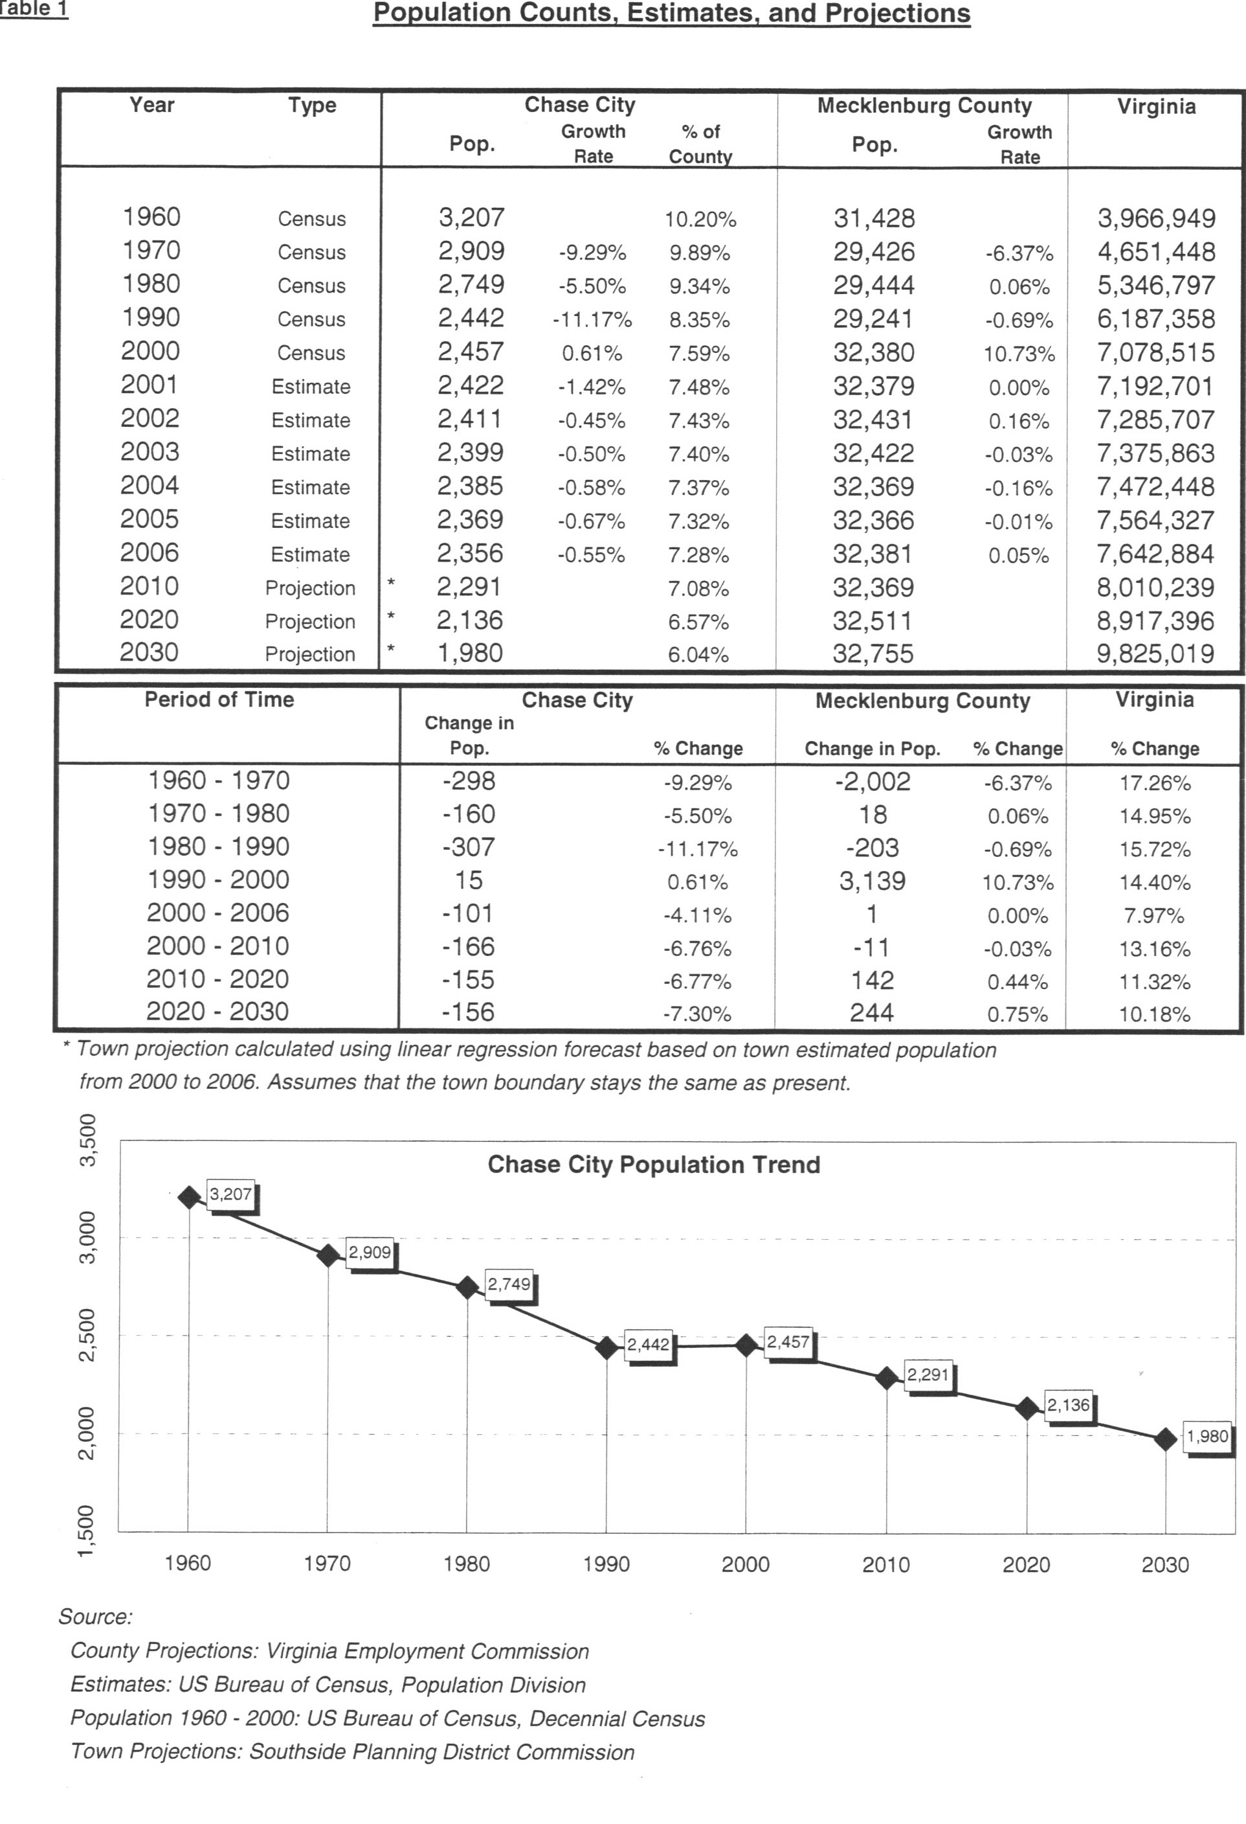
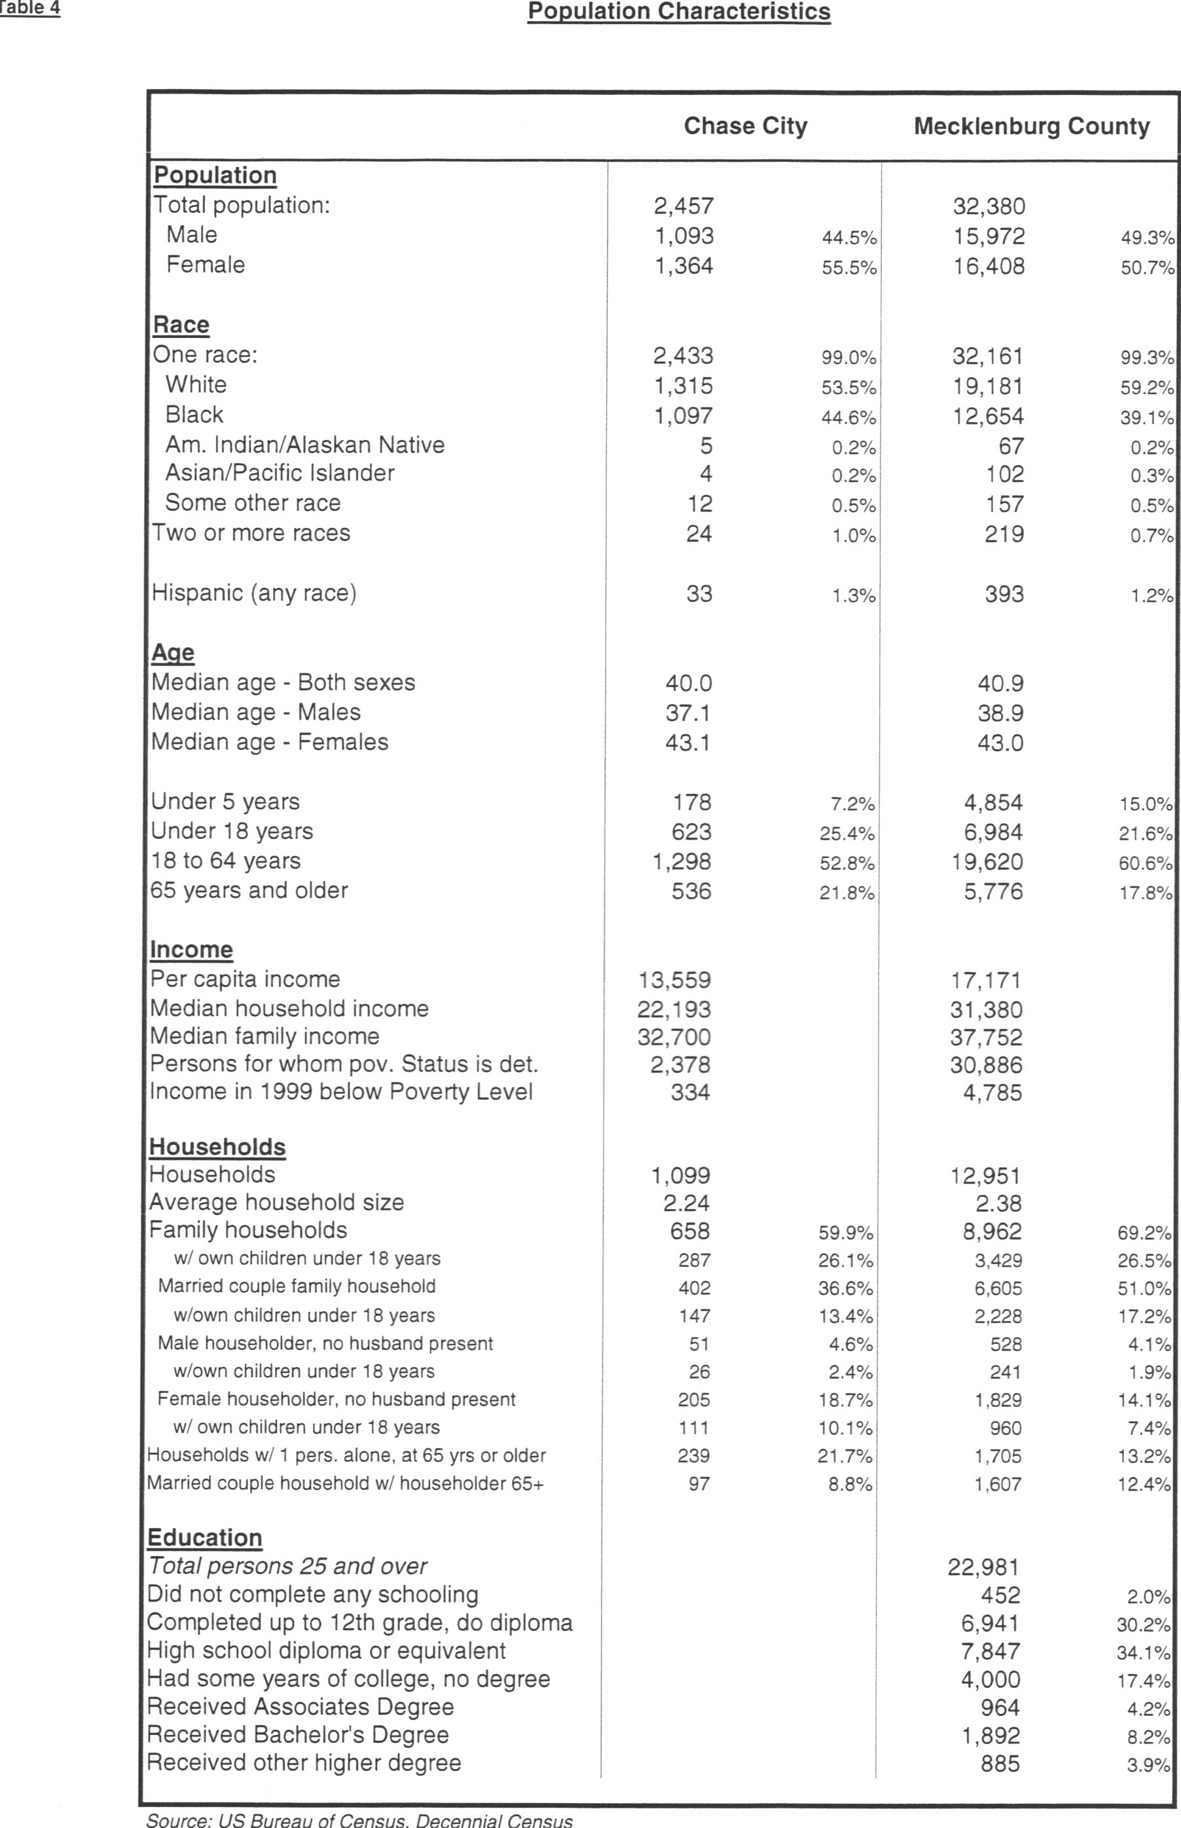
Housing
The availability, condition, and affordability of various types of housing resources within a community are of great importance to community growth and development. Housing conditions are often used as a barometer to gauge a community’s social and economic well-being and the quality of life enjoyed by its residents. Furthermore, suitable housing is a basic requirement of population and economic growth. Also, prevailing housing conditions convey a highly visible message of a community’s commitment to satisfy this need for its current and future residents.
Housing is the dominant land use in the Town of Chase City. The overall housing stock can be described as being in good condition, however; there are sections of deteriorating dwellings within the town. The Town is identifying strategies through the comprehensive plan and zoning ordinance to target special interest and resources to provide increased housing opportunities for area low and moderate income individuals and families.
The Town is confronted with a number of housing problems and needs which, if not given attention, have the certain potential of further deterioration. The presence of substandard housing conditions jeopardizes the health and safety of residents subject to such ill-fated conditions. However, the effects of substandard housing are not limited solely to those who physically reside within these homes. The economic health of the community is adversely affected. In a broader sense, housing is a vital community resource, which if properly maintained will have a good influence, and if not, will impede the future social and economic well-being of the community. In order to attract new citizens and tourists to the town, the town must implement programs which will address these issues. The citizens of the town in general are an important and necessary part of the solution and must be made aware of the benefits of maintaining their properties in good order.
Chase City’s housing stock is characterized by a predominant number of older, single family homes. This type of older housing lends itself to the increased need for maintenance and modernization by owners and landlords to keep their homes and properties safe, sanitary, and in functional working order. While the integrity of many of the town’s older homes is considered good, the existence of substandard housing is evident in certain individual houses and particular neighborhoods. The single most import variable that has contributed to this situation is the lack of financial means by both private owners and the local government required to rectify the problem.
It is a fairly safe assumption that people do not willingly choose to place themselves in the compromised living environment of substandard housing. But for many LMI families their lack of income perpetuates this type of existence. In previous surveys it was determined that a high percentage of the population was LMI. The local government as well would like to see an end to undesirable housing and neighborhood conditions, but remains dependent upon securing funding assistance in order to do so. The Town has made good progress in addressing the situation and has recently completed renovation and upgrades to three different housing apartments, Chase Place, Chase Run, and Maple Manor.
One of the impediments to improving, and some cases, removing houses and commercial buildings that have fallen into serious disrepair and are blight on the community, is the current procedure for correcting these conditions. Under the present procedure the Town relies on the county Building Inspectors to issue building permits and to oversee the conditions of buildings in Chase City. This is not working in the best interest of the Town due to the county’s procedure in dealing with substandard properties. The problem of substandard buildings in the county does not rise to the level of concern that it does in the towns, due its increased visibility. It is recommended that the town pass an ordinance dealing with blight and public nuisances and employ an Enforcement Officer. This would give the Town better control in dealing with these problems.
GOAL: Develop and maintain residential neighborhoods which enhance the living environment for all citizens of Chase City.
- Town zoning provisions should permit a diversity of housing configurations to encourage construction of a variety of dwelling types.
- Town Officials should identify housing units that are in either disrepair or decline and work toward renovation that is cost effective and efficient.
- The Town should enforce property maintenance ordinances to ensure that unsightly and poorly maintained properties are cleaned up.
- Town officials should continue to pursue avenues of financial assistance to develop and implement a comprehensive improvement program for substandard residential structures. The Town should seek available Community Development Block Grant (CBDG) grants as well as other sources to upgrade these properties.
- Although the Town has no authority to determine or require a particular design or construction of buildings, residential or commercial, beyond the requirements of the Zoning Ordinance, it is recommended that the Zoning Administrator and Planning Commission make recommendations to builders and developers by providing examples of what the Town would prefer.
- Town Officials should promote the development of retirement communities, the largest segment of the U.S. Population, over 25% and increasing. The utilization of Condos and cluster developments which require low maintenance will offer housing choices

GOAL: In the zoning of an area, in the Town’s present corporate limits or in the possible Boundary
Adjustment Areas, the Town should consider several factors:
- The highest and best use of the properties based on their suitability for such development. Ensure that there is a balance in their land use plan to address the needs of all income levels with the understanding that market forces greatly influence land use decisions.
- The value of other properties in the area and how their values would be impacted.
- The Town does have planning authority for a two mile radius around its corporate limits. An option specifically for Mecklenburg County and 4 other counties in the state.
- The ability of the Town to provide the necessary services, i.e. water, sewer, garbage collection, street maintenance, and other services
GOAL: Acquire additional land for development through Boundary Adjustment as shown in Appendix C.
- Increase the land available for residential, commercial and industrial use through Boundary Adjustment.
- Allocate suitable areas for desirable low, medium, and high-density residential development.
- Revise Zoning Ordinance to ensure appropriate zoning for the Boundary Adjustment areas.
- Encourage the development of assisted living facilities for residents who need some daily support but are not in need of a nursing home facility.
- Encourage the utilization of Cluster and Residential Development (PRD) concepts in subdivisions in order to preserve the natural beauty in the area.

EMPLOYMENT & COMMERCE

BACKGOUND
A diversity of commercial, industrial, and quasi-public employers provides a stable tax base for the Town and a broad choice of employment opportunities. Tax revenues from employers are crucial in providing public services and amenities to Town residents.
To provide a meaningful economic analysis, it is necessary to look at the economy of Chase City combined with the surrounding communities in Mecklenburg, Halifax, and Lunenburg Counties, since the economics of these jurisdictions are highly intertwined.
BUSINESS CLIMATE
Several major industries have closed in Chase City and in the vicinity beginning in the 1980’s and continuing through 2010. This continues to be of concern to the Town as they continue to try to attract other prospective industries and to foster other economic development projects. Efforts are underway to try to locate land in or near Chase City to establish an industrial park to help attract new industries.
Chase City completed a major downtown revitalization project in the downtown area in 2002. A detailed description of this revitalization project will be outlined in another section of this plan. Several new businesses have located in the downtown area after the revitalization project; however, the need still exists to recruit other businesses to the downtown area to fill the few vacant buildings that remain.
DOWNTOWN REVITALIZATION
As with many municipalities around the state, Chase City’s downtown was deteriorating, reflecting the business climate around the municipality. Many buildings were vacant along the main business corridor, leaving blank storefronts and a negative impression. Utility poles were located along Main Street that included power lines, telephone lines, and cable television lines which were very unsightly. Town Council took steps to address Chase City’s deteriorating downtown and to improve the image by appointing a Downtown Revitalization Committee in 2000. The Committee was represented with merchants, town officials, and interested citizens that developed an action plan to be taken over a two year period.
Town Council and the Downtown Committee, with the assistance of the Southside Planning District Commission, applied and received three (3) grants to revitalize the downtown district. The grants were from the Department of Housing and Community Development (CDBG), the Virginia Tobacco Commission (TIC), and the Virginia Department of Transportation (TEA-21). Total funding from the grants including a local match funding was $2,153,335. The work accomplished in the project was as follows: 1) remove existing utility poles and wires and relocate the utilities in the rear of the Main Street stores; 2) removed existing sidewalks, ran new electrical service in the new formed sidewalks and poured new colored stamp concrete sidewalks on both sides of the Main Street; 3) installed new decorative street lights, renovated store façades on Main Street; 4) erected a Main Street Pavilion; 5) placed seasonal banners on new street lights. 6) purchased new decorative benches and trash cans for Main Street.; 7) planted new flowering trees on both sides of Main Street.
The Downtown Revitalization Project was completed in 2002 and has greatly enhanced the appearance of downtown Chase City. Several new businesses have located on Main Street since it was renovated and efforts are being made to attract others.
Chase City’s Main Street, due to its length and visibility, was transformed into one of the most attractive downtowns in the area. In addition to that project, the development of the Estes Building, the crown jewel of the downtown area, offers an attractive Business and Community Center as well as educational programs through Southside Virginia Community College. This multi-million dollar facility has excellent potential in the future growth of the town.
EMPLOYMENT
The number of employed persons 16 years or older has increased for the first time since 1980, from 797 in 2000 to 930 in 2010 or 16.6 % as indicated in Table 5. Employment in the town peaked in 1970 with 1,375 dropping to 797 in 2000.
As in most towns in widely agricultural area, such as Mecklenburg, much of the municipality’s commercial activity is dependent on the farmers. If agribusiness suffers, so will the town. The tobacco warehouses have all closed in town since tobacco is no longer sold under the auction system, and is now sold under contract to the tobacco companies. The new contract system has resulted in more tobacco grown by fewer farmers with the elimination of the quota system; however, only the larger farm operations can compete in this type of market. The positive side is it has made tobacco grown in the area more competitive and revived what had been a declining market for many years. At the same time, more farmers are raising beef cattle and soy beans that formerly raised tobacco.

GOAL: Maintain and expand the employment base of the Town and strengthen the present businesses and industries.
- Town officials should work with local business and industry representatives to insure that adequate water and sewer capacity is available for future expansions.
- Town officials should seek out funding to assist with maintaining and replacing old and antiquated water and sewer services.
- Town officials should promote the idea of Chase City being a good place to locate or expand a business.
- Town officials should promote the availability of redundant electricity service in Chase City to the data center market to attract additional high-tech companies.
GOAL: Encourage a range of goods and services to meet the needs of the residents. Maintain the economic viability of the existing downtown commercial area.
- Provide for a mixture of retail stores, business and government offices, restaurants, personal and profession services, financial services, and other related and appropriate uses within the Town.
- Town Officials should recognize the Downtown business district as the center of retail and commercial business activity.
- Ensure the Town land-use regulations permit a variety of commercial and business uses to promote diversity and flexibility in business location decisions.
- Town Officials should work with local business owners to help retain existing businesses and promote their expansion.
GOAL: Increase the perception of the Town as a desirable place to shop.
- The town should continue to improve the appearance of Main Street and seek the cooperation of local businesses in this effort.
- Town officials should seek out the types of businesses that would compliment and expand the present mix of goods and services available to town residents.
- An inventory of vacant or underutilized commercial buildings should be completed to determine opportunities for business expansion or recruitment.
- The Town should encourage special events throughout the year to attract visitors such as walking and driving tours of the areas. Also encourage expanded use of the Estes Community Center and the Robert E. Lee Auditorium for special events.

ECONOMIC DEVELOPMENT
The state has realized for at least 20 years that the rural economies were declining due to many factors. One of the largest contributors to this were trade agreements (NAFTA) which caused a lot of our manufacturing to move off shore due principally to cheaper labor and less regulation. This has impacted the textile industry particularly hard and resulted in the closing of most of the related industries in our area, thus decreasing employment. The difficulty in attracting new companies was the lack of the required upscale labor force and the continued outsourcing of companies to other countries.
Table 6 shows a drop in the number of establishments in manufacturing with an increase in health care and food service related businesses. Although, there has been a slight drop in retail establishments, this trend seems to be reversed recently with a number of new restaurants and service organizations opening. It should be noted that a number of residents work out of town, particularly in the South Hill area, due to the number of companies operating there. When Microsoft opens in Boydton and the possibility of other companies being attracted to the new IT Park in the Clarksville area, the future for jobs in the area should show improvement. Although, the Town hopes to attract companies to Chase City, the possibility of upscale jobs in the area will be of benefit to the town.

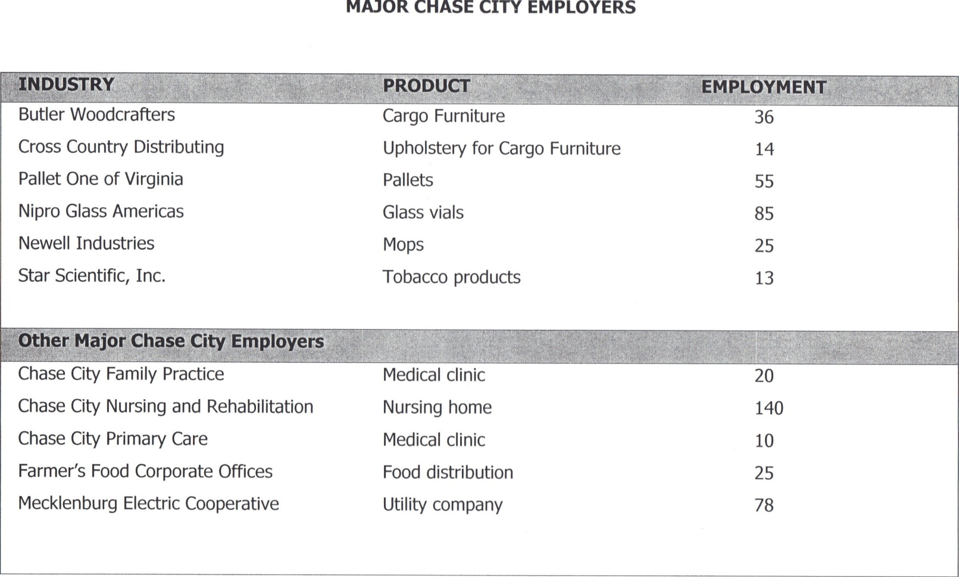
RURAL VIRGINIA PROSPERITY COMMISSION
In 2000, the Legislature created a Commission to study the rural declining economies, the Rural Virginia Prosperity Commission (RVPC). This Commission was charged with the task of studying the rural areas of the state and identifying the factors adversely affecting them and providing recommendations to the Legislature on corrective measures. The RVPC conducted meetings around the state with business and elected officials to solicit their input on the problems they faced along with their recommendations. On December 1, 2001, the Commission delivered their report to the Governor. One of the primary recommendations identified the need for a high-speed broadband fiber optic network, highlighted as a necessity in attracting industry now and in the future. Also recommended was the creation of a Secretary of Agriculture, since agribusiness in Virginia is one of the largest of any state in the U.S.
The completion of this study was instrumental in the development of one of the most advanced high-speed networks in the country which is provided by Mid-Atlantic Broad Band Network. This fiber-optic network extends through Mecklenburg County along Highway 58 east from South Hill to Boydton to Clarksville. In addition this line runs along Highway 92 from Boydton through Chase City to the Industrial Park. The value of access to this network resulted in EDS (now HP) locating in Clarksville. More recently the internet giant Microsoft, has located in the Industrial Park outside Boydton and has invested over $500 million dollars initially.
Chase City recently connected to the Roanoke River Service Authority, creating access to an unlimited source of water, another important asset for future commercial and industrial development. This has become increasingly important due to the scarcely of potable water in many sections of the country. Additionally, the town has access to redundant sources of electric power which is necessary for many companies requiring uninterrupted sources of power. Also, Chase City has access to the only railroad line in the county. It is impossible to estimate the future value these services will be to the Town and the County.
Although, Chase City has struggled economically for many years, the opportunities for positive change look encouraging for the future. In an area where the services required for the companies of the future, Chase City has assets that make it a desirable location. Most rural areas of the country and the state do not have access to this valuable infrastructure.
Chase City does have one significant problem, one faced by many towns in Virginia, the lack of land available for development. Most towns have the same land area since their inception. This has created a situation where there is limited land available for development; there is little opportunity for future development. Chase City needs to expand its boundaries if it and the county are to benefit from the valuable assets mentioned above. Any future development in the county will necessarily require a cooperative effort between Mecklenburg County and the towns. The towns provide and maintain the water and sewer lines which are critical to any development in the County; however, they cannot do so without benefiting from the increased taxes generated from this development. The current State laws on annexation make the process so difficult that few towns can afford to go through that process. The Towns and the County need to explore ways to work together in order to insure the area benefits from the opportunities that are available. Failure to do so will only result in decreased economic activity in the area, both for the towns and the County as a whole.
In an attempt to address these challenges, the Town has identified areas that are attractive for Boundary Adjustments in the future. These areas will be discussed in detail in a later section with an emphasis on how they might be used to the benefit of the area.

PUBLIC SERVICES
Natural Growth Determinants
Growth is influenced by the characteristics of the natural environment. While some natural features encourage and enhance development, others limit land uses and the extent of their growth. Analysis of soils and other natural features provide a means for determining the development capacity of the land.
Topography: The topography of Chase City is typical of Mecklenburg County and South Central Virginia. The elevation above sea level is with surface area described as level to gently rolling hills.
Soils : Soil type is an important factor in the determination of land use. Predominant soil types within Chase City are Georgeville silt loam, rolling phase and undulating phase. The septic suitability of soils acts as a growth determinant for urban land uses. Septic suitability determines the feasibility and cost of growth, particularly residential, in areas outside of sewage service areas. Soil suitability within and outside the corporate limits of Chase City rank fair with individual inspection needed for new development areas to insure this rank.
Water Resources: In the past Chase City has utilized 13 underground wells with approximately 18 to 350 gallons per minute pumped on the average. The relatively large yields of the municipality were attributable partly to the low topographic locations in areas of perennial surface drainage. Although these wells have supported the Towns water needs in the past, it was not sufficient to support an increase in usage brought on by new industry and commercial use. In 2012 the Town was able to connect to the Roanoke River Service Authority which draws water from the Gaston Lake Reservoir. This will enable the Town to meet any increased water demands brought on by growth in the future.
Community Facilities & Services
Community Facilities and Services include all public facilities such as parks, libraries and schools. Also included are public services such as provisions for water and sewer, emergency and health services, transportation, and public safety. These manmade features affect growth and land use decisions. As indicated in the Survey, respondents indicated that these facilities had a positive effect on their quality of life. Another important aspect contributing to community growth and sustainability is the downtown revitalization which is included in this section. These facilities act as an attraction as well as an enhancement for development and will impact future growth and land use decisions. The location of the Town’s facilities is shown in figure 3.
Public Safety:
The combined fire and police facility, located in downtown Chase City on 2nd Street was renovated in 1998. This included the addition of a new apparatus room to house existing fire facilities and remodeling existing areas into meeting quarters, a lobby, offices, a dispatch room, kitchen facilities and equipment rooms for storage of fire gear. A modern fire/police station to house the ever increasing number of fire trucks and police vehicles is important in providing adequate protective services for residents, agricultural land uses and commercial and industrial establishments.
The Chase City Volunteer Fire Department has 41 members, all volunteers. It covers 216 square miles in Mecklenburg County, and some areas of Lunenburg and Charlotte Counties. The firefighting equipment consists of 3 engines, a tanker truck, brush truck, support truck, Chief’s vehicle, hazardous materials trailer, and a couple of personnel carriers. Their training consists of a wide variety of classes starting at Firefighter Level 1 & 2, Hazardous Materials Awareness and Operations, Fire Service Instructor, Vehicle Rescue Awareness, Operations and Technician, Rope Rescue, Farm Machinery Rescue, Emergency Vehicle Operator Course, Fire Office 1, CPR, Emergency Medical Technicians and Intermediate.
The Chase City Rescue Squad, Inc is comprised of a combination of paid and volunteer members, consisting of 5 full time members, 8 part-time members, and 15 volunteers. Training consists of CPR, Emergency Vehicle Operators Course, Emergency Medical Technicians, Intermediate, and Paramedic. We also have several people trained in Rope Rescue Awareness and Operations, Vehicle Awareness, Operations and Technician, Hazardous Materials Awareness and Operations. Also, they have 2 CPR instructors and an instructor for Emergency Vehicle Operator. Their fleet of vehicles consists of 3 Advanced Life Support ambulances, one Advanced Life Support Chase vehicle, and a utility van.
Chase City Police Department is comprised of 9 Officers, a Chief and two Sergeants. All officers are certified and well trained. The department is well equipped and provides around the clock protection for the citizens. While the Town has excellent facilities for the police, fire and rescue personnel and equipment, crime is on the increase and drugs continue to invade the County and towns. Therefore, all the area law enforcement agencies must work together to fight this plague. The Southside Drug Task Force was created for this reason. The Task Force is comprised of six members, State Police Coordinator, two officers from Mecklenburg County, and one officer from the Towns of Chase City, Clarksville, and South Hill.
Of particular concern is the increased demands made on the rescue squad, particularly with an aging population. In addition, the extensive training required has made it more difficult to attract volunteers resulting in most squads having more paid members, particularly during the daytime. This increases the cost of providing these services, a factor which could have an adverse effect in the future.
GOAL: Operate and maintain a Police Department, Fire Department and Rescue Squad sufficiently manned to meet the needs of the current population and any anticipated growth.

- Town officials should work with the Police Department, Volunteer Fire Department and Rescue Squad to ensure that all residents continue to receive quality police, fire, and rescue services.
- Town officials should monitor regularly the volunteer fire and rescue squads and offer technical and financial assistance as needed to ensure that these vital services meet state requirements and residents needs.
- Town officials should continue to provide police services to its residents on a 24-hour basis. Officers should continue to exceed the minimum training requirements mandated by the state.
- Town officials should ensure that officers are provided with vehicles and other equipment necessary to meet job demands.

Health Facilities
The Chase City Family Practice is located on Main Street and offers extensive medical and emergency services. The Clinic has three physicians and a nurse practitioner on staff. It is affiliated with Halifax Regional Hospital located in South Boston.
The Chase City Primary Care, located at Fifth and Boyd Street is affiliated with the Community Memorial Healthcenter, located approximately 22 miles from Chase City in South Hill. This facility is staffed by a full-time Nurse Practitioner and a physician on certain days of the week.
The Chase City Health and Rehab Center opened in 2004 with 120 bed center that offers care for short-term and long-term. This includes an advanced Alzheimer’s and dementia care unit. They also offer Occupational and Speech therapy for transitional patients.
EDUCATION FACILITIES
The children of Chase City attend Chase City Elementary School, Bluestone Middle School, and Bluestone Senior High School. These schools are operated by the Mecklenburg County Public School Board. The Elementary School is located just outside the town limits on Boyd Street and Highway Forty-Seven.
Although the schools are the responsibility of the County, the quality of the public education and facilities are important to the town. Our students receive an excellent education, enabling them to compete favorably in college and the business world. However, the school buildings, based on the survey and input from citizens and business leaders, are substandard. Companies and employees considering locating in the area often get a negative impression when visiting the outdated school buildings, resulting in their favoring other communities. Town Officials and business leaders should provide support and encouragement to the County Supervisors and School Board in an effort to upgrade these important facilities. Although the Survey indicated the respondents agreed, few felt they were willing to pay more taxes in order to finance these schools. An effort needs to be made to increase public awareness on the value of improved facilities and the importance of their support.
The Southside Virginia Community College has two main campuses in the region located at Alberta, the eastern campus and in Keysville, the western campus and serves 10 counties in the Southside area. It also has 6 satellite offices located strategically throughout the region, one of which is located in Chase City in the Estes Community Center. This multi-million dollar center has excellent facilities and is an important asset to the town and the area. At the present LPN classes are offered here with the potential for many other classes through the college in the future. SVCC is affiliated with Old Dominion University with Bachelor, Masters, and PhD programs available. The college also has one of the highest dual enrollments in the state which allows many of our high school students to complete their Associates Degree when they graduate from high school which, in many cases, allows them to enter a four year University as a junior. This is a significant savings especially when college costs are escalating rapidly.

Recreation & Entertainment

While the Town has some athletic/recreation facilities around town it is obvious that the citizens believe them to be inadequate. Based on the Survey, the respondents indicated a high preference for a community center, Bowling Alley, and Biking/Walking trails. Although there are Basketball Courts and a playground area at the local school site, there is demand for more. A ballpark is located at the American Legion with a larger array of activities available at the Community Park. This park offers a softball and football field with bleachers, refreshment area, basketball courts, playground activities, and picnic facilities. The Town should consider upgrading and increasing facilities that cater to young people. Some of the comments in the Survey indicate a need for such facilities for teens and young adults. This type of activity has many benefits, not the least of which, is dealing with the indicated drug problems in the area.
One of the great advantages in living in the area is the proximity to Buggs Island Lake (John H. Kerr Reservoir) a 50,000 acre lake which offers excellent outdoor recreation. The opportunity for camping, boating, water-skiing and some of the best freshwater bass fishing on the East Coast is a huge attraction, not only to tourists, but to those considering making Chase City their home. It draws Bass Federation tournaments annually as well as Professional Boat Races.
The Robert E. Lee Community Center offers a seated auditorium for presentations and plays. The old Mecca Movie Theater is currently vacant, but in good condition. The Survey respondents emphasize strongly the need for a movie theater in town as well as a bowling alley. Although, this would be desirable, it is questionable whether this is economically feasible. The conditions which have seen the demise of many small town theaters in the last 50 years still exist today. Having the population to support this enterprise is the key ingredient, not to mention the availability of unlimited entertainment through television and other venues.

Cultural Amenities
MacCallum More Museum and Gardens, located on Hudgins Street is a treasure worthy of statewide recognition. Now open to the public, the gardens were begun in 1929 by Lucy Morton Hudgins, wife of Edward Wren Hudgins, Chief Justice of the Virginia Supreme Court. Their son, William Hudgins traveled extensively while a Commander in the U.S. Navy and in service to President Truman and Admiral Carney, Commander in Chief of NATO. The sculptures and artworks he sent home from his journeys were incorporated into the Gardens creating an outdoor art museum. Also on the grounds is a museum containing an extensive exhibition of local Indian artifacts.

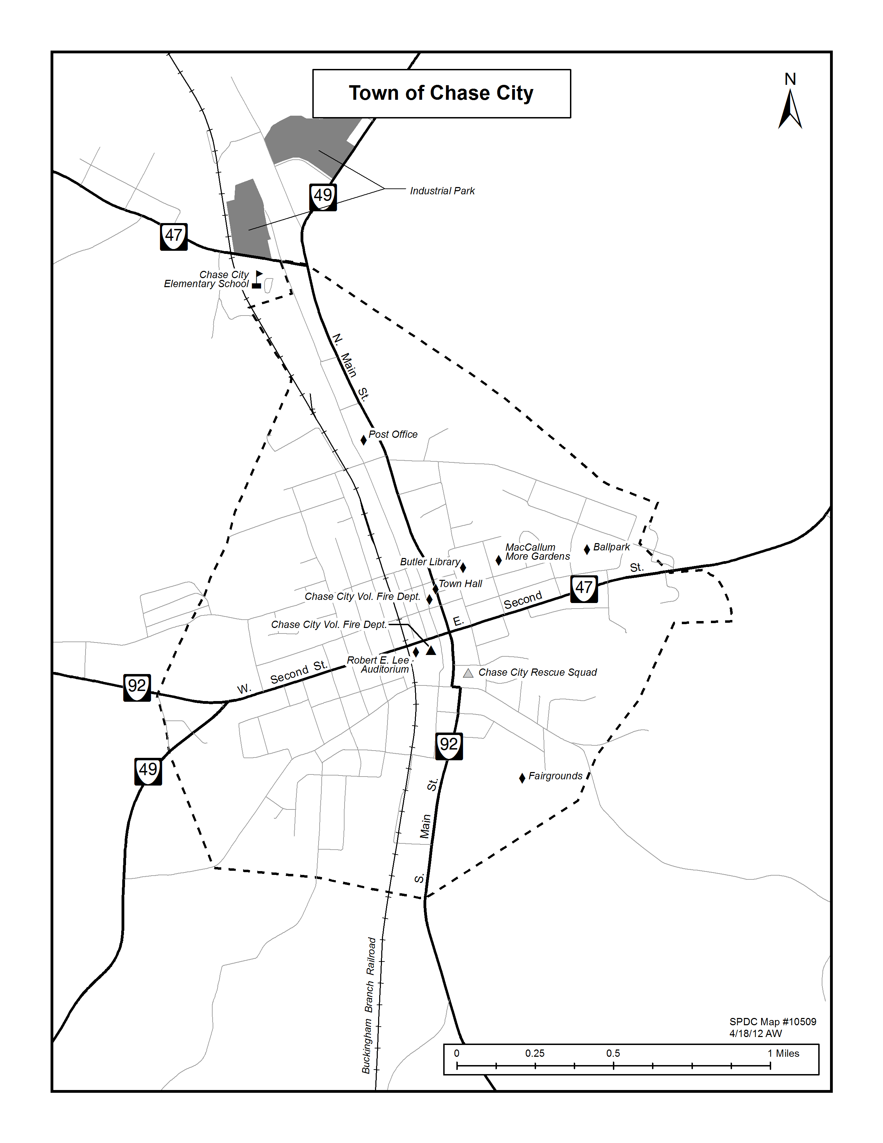
fffff
COMMUNITY ATTITUDES
The purpose of planning is to devise a guide for community development; therefore, it is important to determine what kind of community it is that people wish to develop. However, rather than government officials simply making a unilateral determination of what is good for the community, a better approach is to consult the citizens for their input. In this way local problems and issues can be identified as well as giving the citizens ownership in the process. Utilizing this information, the Comprehensive Plan can be made more responsive to the actual needs of the community.
Determining Community Attitudes
Among the most common methods that officials obtain input are through discussions with citizens groups, complaints, public hearings, etc. Although useful, they do not easily lend themselves to systematic examination and evaluation and cannot be expected to be representative of the entire population.
One of the best sources of information is a well-constructed survey, properly conducted and analyzed; it offers an excellent means for officials to gain perspective of community opinions. It is the most efficient way to obtain information on citizen viewpoints on various local issues, their satisfaction with the quality of specific government services, and potential demands for new services. Survey information can be useful in program and policy planning and in resource allocation. The finding can help determine budget priorities, identify needed changes and guide officials in their formulation of policies.

CITIZENS SURVEY
Recognizing the need to consult citizens on issues concerning the community’s future, the Chase City Planning Commission selected the Survey approach. The following topics were covered in the survey.
Shopping locations Recreation Boundary Adjustment
Library Job opportunities Town Administration
Industrial growth Population growth Economic growth
Public School System Police Protections Housing
Medical facilities Town services Emergency Services
On November 1, 2011, a questionnaire was developed, distributed, and mailed to the residents of Chase City, requesting they be returned by December 1, 2011 (see attached survey). A total of 1100 surveys were mailed resulting in 112 responses, representing a 10 % return, an average response based on surveys in general.
ANALYSIS OF RESULTS
Despite the best efforts of the Planning Commission, the results of the survey are imperfect; therefore, the Commission was careful in drawing conclusions. Nevertheless, within this section several salient issues of importance to Chase City’s future were disclosed, and should be addressed during the formulation of the plan.
Section A of the survey covered a broad range of life issues, availability of services, employment, etc. As expected, citizens were highly satisfied with the rural character, natural beauty, and access to outdoor recreation, hunting, fishing, and boating in the area and want to preserve its unique way of life. The Lake’s attraction to campers, boating enthusiasts, fisherman, in addition to tourists, is something they want to protect.
At the same time, a majority favor growth in population, new businesses, industrial development, the expansion in the supply of housing and commercial development. As noted earlier, there is a shortage of vacant land in the town for increased housing and commercial development. Therefore, these responses would indicate the need to expand the Town’s boundaries in order for this to be accomplished.
Section B of the survey deals with the satisfaction with the various Town services. The Police Department, Fire Department, and Rescue Squad all received high ratings on satisfaction. The Estes Community Center and the Butler Library both received high satisfaction ratings. The Town Council, Administration, and Chamber of Commerce received satisfactory ratings; however, a number of people expressed no opinion. The Planning Commission and the Building Officials Office received somewhat lower ratings which may be attributed to the lack of understanding of their functions by the public.
Section C. All of section C received high emphasis on the importance of each of the categories to the town. The survey gives strong indication of the need to attract more business and industry and to create more job opportunities. Since most of the respondents were over the age of 55, it should be noted that these figures would be considerably higher if there had been a greater response for younger respondents. This would also affect the responses on affordable housing, since most responders were homeowners. The most troubling aspect is the absence of responses from young couples in the Town. This results in limited input on the Public Schools since the majority of respondents had no children of school age and thus had little contact with the schools. It also explains why a large percentage was in favor of more lodging units, attracting more festivals/special events, and town beautification programs.
Section D. In this section the respondents indicated that if additional funds were needed for the desired improvements, they should come from food, lodging, and business taxes rather than an increase in real estate and property taxes. This reinforces what is generally known by elected officials, people want more services, but are unwilling or unable to pay for them through increased taxation.
A majority felt the Town should put emphasis on the following land uses; light industrial, commercial/retail, and housing, both retirement and single family. Since the available land for such development in Town is limited, the need for additional land in the proposed areas by boundary adjustment is further substantiated.
The Respondents indicated the recreational facilities they would use if available. Their top preferences were a recreation center, bowling alley, and bike/walking trails. However, one category that was not on the survey, but was frequently mentioned in the comment section, was the desire for a Movie Theater. Second tier requests were for Soccer fields, swimming pools, and tennis courts.
As indicated earlier, the survey, although not scientific, gives a strong indication of what the citizens consider the most important factors in making Chase City an outstanding place to live, work, and play. They want to maintain what is unique about the area, while providing the necessary infrastructure to enable the Town to grow and prosper economically.

CHASE CITY SURVEYS | got back 112 |  |  |  |  |  |  | Based on 112 Forms
Section A |  | Satisfied | Not Satisfied | No Opinion | Total # Responses | Did not Answer at All | Based on All 112 Forms | % Satisfied | % Not Satisfied | % No Opinion | Did not Answer at All
1. Small Town Atmosphere |  | 83 | 13 | 9 | 105 | 7 | 112 | 74% | 12% | 8% | 6%
2.Rural Character |  | 78 | 15 | 12 | 105 | 7 | 112 | 70% | 13% | 11% | 6%
3.Natural Beauty |  | 74 | 18 | 10 | 102 | 10 | 112 | 66% | 16% | 9% | 9%
4. Access to rivers and Lakes |  | 86 | 7 | 13 | 106 | 6 | 112 | 77% | 6% | 12% | 5%
5. Hunting/Fishing |  | 64 | 8 | 32 | 104 | 8 | 112 | 57% | 7% | 29% | 7%
6.Cultural Opportunities |  | 26 | 49 | 24 | 99 | 13 | 112 | 23% | 44% | 21% | 12%
7. Recreation Facilities |  | 25 | 65 | 11 | 101 | 11 | 112 | 22% | 58% | 10% | 10%
8. Restaurant Availability |  | 26 | 71 | 6 | 103 | 9 | 112 | 23% | 63% | 5% | 8%
9. Entertainment Opportunities |  | 13 | 91 | 3 | 107 | 5 | 112 | 12% | 81% | 3% | 4%
10. Shopping Opportunities |  | 9 | 75 | 2 | 86 | 26 | 112 | 8% | 67% | 2% | 23%
11.Favorable Tax Rate |  | 60 | 36 | 11 | 107 | 5 | 112 | 54% | 32% | 10% | 4%
12. Employment Opportunities |  | 6 | 73 | 15 | 94 | 18 | 112 | 5% | 65% | 13% | 16%
13. Quality of Healthcare |  | 53 | 39 | 16 | 108 | 4 | 112 | 47% | 35% | 14% | 4%
14. Services for Senior Citizens |  | 23 | 52 | 19 | 94 | 18 | 112 | 21% | 46% | 17% | 16%
15. Historic Buildings and Sites |  | 54 | 27 | 25 | 106 | 6 | 112 | 48% | 24% | 22% | 5%
16.Sense of Place |  | 52 | 20 | 34 | 106 | 6 | 112 | 46% | 18% | 30% | 5%
17.Community Spirit and Pride |  | 44 | 38 | 15 | 97 | 15 | 112 | 39% | 34% | 13% | 13%
18.Civic/Volunteer Groups |  | 59 | 26 | 16 | 101 | 11 | 112 | 53% | 23% | 14% | 10%
19. Friendly People |  | 78 | 20 | 6 | 104 | 8 | 112 | 70% | 18% | 5% | 7%
20. Proximity to Family |  | 69 | 14 | 19 | 102 | 10 | 112 | 62% | 13% | 17% | 9%
21. Churches |  | 84 | 9 | 8 | 101 | 11 | 112 | 75% | 8% | 7% | 10%
22. Quality of Roads |  | 57 | 41 | 12 | 110 | 2 | 112 | 51% | 37% | 11% | 2%
23. Public Schools |  | 52 | 30 | 22 | 104 | 8 | 112 | 46% | 27% | 20% | 7%
24. Adult Education Opportunities |  | 61 | 28 | 17 | 106 | 6 | 112 | 54% | 25% | 15% | 5%
25. Police Protection |  | 75 | 19 | 12 | 106 | 6 | 112 | 67% | 17% | 11% | 5%
26. Proximity to work |  | 38 | 31 | 32 | 101 | 11 | 112 | 34% | 28% | 29% | 10%
27. Access to Air Travel |  | 22 | 50 | 31 | 103 | 9 | 112 | 20% | 45% | 28% | 8%
28. Availability of Housing |  | 41 | 34 | 19 | 94 | 18 | 112 | 37% | 30% | 17% | 16%
29. Affordability of Housing |  | 41 | 37 | 18 | 96 | 16 | 112 | 37% | 33% | 16% | 14%
30. Commercial Development |  | 9 | 89 | 10 | 108 | 4 | 112 | 8% | 79% | 9% | 4%
31. Industrial Development |  | 10 | 78 | 8 | 96 | 16 | 112 | 9% | 70% | 7% | 14%
32. Town Management |  | 58 | 32 | 18 | 108 | 4 | 112 | 52% | 29% | 16% | 4%
33. Town Utility Services |  | 77 | 21 | 7 | 105 | 7 | 112 | 69% | 19% | 6% | 6%
34. Quality Neighborhoods |  | 51 | 41 | 16 | 108 | 4 | 112 | 46% | 37% | 14% | 4%
35. Less Congestion |  | 73 | 9 | 23 | 105 | 7 | 112 | 65% | 8% | 21% | 6%
36. Social Services |  | 44 | 26 | 25 | 95 | 17 | 112 | 39% | 23% | 22% | 15%
37. Quiet and Peacefulness |  | 80 | 17 | 13 | 110 | 2 | 112 | 71% | 15% | 12% | 2%
 |  | 1855 | 1349 | 589 | 3793 | 351 | 4144 | 45% | 33% | 14% | 8%
 |  |  |  |  |  |  |  | Based on 115 Forms
Section B |  | SATISFIED | Not satisfied | No Opinion | Total # Responses | Did not Answer at All |  | % Satisfied | % Not Satisfied | % No Opinion | Did not Answer at All
1. Town Water/Sewer |  | 79 | 30 | 2 | 111 | 1 | 112 | 71% | 27% | 2% | 1%
2. Garbage Collection |  | 96 | 8 | 4 | 108 | 4 | 112 | 86% | 7% | 4% | 4%
3. Town Streets |  | 65 | 39 | 5 | 109 | 3 | 112 | 58% | 35% | 4% | 3%
4.Town Police Department |  | 78 | 15 | 8 | 101 | 11 | 112 | 70% | 13% | 7% | 10%
5. Chase City Fire Department |  | 98 | 3 | 6 | 107 | 5 | 112 | 88% | 3% | 5% | 4%
6. Chase City Rescue Squad |  | 83 | 14 | 8 | 105 | 7 | 112 | 74% | 13% | 7% | 6%
7. Town Zoning Administration |  | 40 | 23 | 36 | 99 | 13 | 112 | 36% | 21% | 32% | 12%
8. Recycling Center |  | 29 | 48 | 26 | 103 | 9 | 112 | 26% | 43% | 23% | 8%
9. Town Administration |  | 53 | 28 | 22 | 103 | 9 | 112 | 47% | 25% | 20% | 8%
10. Planning Commission |  | 35 | 33 | 20 | 88 | 24 | 112 | 31% | 29% | 18% | 21%
11. Butler Memorial Library |  | 89 | 9 | 6 | 104 | 8 | 112 | 79% | 8% | 5% | 7%
12 Chamber of Commerce |  | 62 | 24 | 26 | 112 | 0 | 112 | 55% | 21% | 23% | 0%
13. Town Council |  | 53 | 24 | 27 | 104 | 8 | 112 | 47% | 21% | 24% | 7%
14. YMCA |  | 56 | 21 | 25 | 102 | 10 | 112 | 50% | 19% | 22% | 9%
15. Estes Community Center |  | 77 | 13 | 17 | 107 | 5 | 112 | 69% | 12% | 15% | 4%
16. Woodland Cemetery |  | 65 | 12 | 29 | 106 | 6 | 112 | 58% | 11% | 26% | 5%
17. Town Brush & Leaf Removal |  | 76 | 19 | 10 | 105 | 7 | 112 | 68% | 17% | 9% | 6%
18. Snow Removal |  | 85 | 14 | 13 | 112 | 0 | 112 | 76% | 13% | 12% | 0%
19. Public School System |  | 55 | 28 | 23 | 106 | 6 | 112 | 49% | 25% | 21% | 5%
20. County Landfill |  | 53 | 20 | 37 | 110 | 2 | 112 | 47% | 18% | 33% | 2%
21. Building Official Office |  | 36 | 17 | 34 | 87 | 25 | 112 | 32% | 15% | 30% | 22%
22. County Government |  | 39 | 37 | 23 | 99 | 13 | 112 | 35% | 33% | 21% | 12%
 |  | 1402 | 479 | 407 | 2288 | 176 | 2464 | 57% | 19% | 17% | 7%
 |  |  |  |  |  |  |  | Based on 115 Forms
SECTION C. |  | IMPORTANT | Not Important | No Opinion | Total # Responses | Did not Answer at All |  | % Satisfied | % Not Satisfied | % No Opinion | Did not Answer at All
1.Attracting Business /Industry |  | 108 | 3 | 1 | 112 | 0 | 112 | 96% | 3% | 1% | 0%
2.Retaining Existing businesses |  | 106 | 1 | 5 | 112 | 0 | 112 | 95% | 1% | 4% | 0%
3. Controlling Growth & Development |  | 75 | 25 | 11 | 111 | 1 | 112 | 67% | 22% | 10% | 1%
4. Providing Job Opportunities |  | 108 | 3 | 2 | 113 | -1 | 112 | 96% | 3% | 2% | -1%
5. Controlling Crime |  | 103 | 1 | 3 | 107 | 5 | 112 | 92% | 1% | 3% | 4%
6. Regional Cooperation |  | 84 | 6 | 13 | 103 | 9 | 112 | 75% | 5% | 12% | 8%
7.Cost of Public Services |  | 96 | 5 | 3 | 104 | 8 | 112 | 86% | 4% | 3% | 7%
8. Repairing and Improving Roads |  | 100 | 6 | 3 | 109 | 3 | 112 | 89% | 5% | 3% | 3%
9. Public School Improvements |  | 90 | 5 | 8 | 103 | 9 | 112 | 80% | 4% | 7% | 8%
10. Production of Agriculture |  | 84 | 8 | 13 | 105 | 7 | 112 | 75% | 7% | 12% | 6%
11. Affordable Housing |  | 94 | 15 | 6 | 115 | -3 | 112 | 84% | 13% | 5% | -3%
12. Maintaining Quality Neighborhoods |  | 105 | 5 | 2 | 112 | 0 | 112 | 94% | 4% | 2% | 0%
13. Services for Senior Citizens |  | 102 | 5 | 5 | 112 | 0 | 112 | 91% | 4% | 4% | 0%
14. Town Boundary Adjustments |  | 68 | 24 | 16 | 108 | 4 | 112 | 61% | 21% | 14% | 4%
15. Expanding Recreation Activities |  | 85 | 9 | 7 | 101 | 11 | 112 | 76% | 8% | 6% | 10%
16. Adding Parks and Sports Fields |  | 79 | 22 | 7 | 108 | 4 | 112 | 71% | 20% | 6% | 4%
17. Improving Fire/Rescue Services |  | 86 | 8 | 12 | 106 | 6 | 112 | 77% | 7% | 11% | 5%
18. Ensuring Water and Sewer Services |  | 98 | 3 | 3 | 104 | 8 | 112 | 88% | 3% | 3% | 7%
19. Preserving the Environment |  | 93 | 8 | 9 | 110 | 2 | 112 | 83% | 7% | 8% | 2%
20. Availability of Day Care |  | 79 | 12 | 14 | 105 | 7 | 112 | 71% | 11% | 13% | 6%
21. Conducting Long Range Planning |  | 87 | 12 | 7 | 106 | 6 | 112 | 78% | 11% | 6% | 5%
22. More Shopping Opportunities |  | 97 | 5 | 4 | 106 | 6 | 112 | 87% | 4% | 4% | 5%
23. More Restaurant Opportunities |  | 93 | 14 | 5 | 112 | 0 | 112 | 83% | 13% | 4% | 0%
24. Proving Youth Activities |  | 93 | 9 | 3 | 105 | 7 | 112 | 83% | 8% | 3% | 6%
25. Providing Local Transportation |  | 63 | 32 | 14 | 109 | 3 | 112 | 56% | 29% | 13% | 3%
26. Attracting Tourism |  | 77 | 20 | 9 | 106 | 6 | 112 | 69% | 18% | 8% | 5%
27. More Festivals/Special Events |  | 77 | 19 | 11 | 107 | 5 | 112 | 69% | 17% | 10% | 4%
28. Town Beautification Programs. |  | 84 | 13 | 11 | 108 | 4 | 112 | 75% | 12% | 10% | 4%
 |  | 2514 | 298 | 207 | 3019 | 117 | 3136 | 80% | 10% | 7% | 4%

SECTION D
QUESTION NO 1 | If additional public funds are needed to improve facilities or services in the future - Which of the following would you want to be raised?
 |  | Number | Percentage based on 112
Real Estate Taxes |  | 21 | 19%
Personal Property |  | 24 | 21%
Service Fees |  | 53 | 47%
Utility Fees |  | 17 | 15%
Meals Tax |  | 28 | 25%
Business License |  | 39 | 35%
No 2 | Which of the following land uses should Chase City encourage?
 |  | Number | Percentage based on 112
Commercial/Retail |  | 79 | 71%
Office/Professional |  | 49 | 44%
Light Industrial |  | 61 | 54%
Mobile Homes |  | 8 | 7%
Single Family Houses |  | 53 | 47%
Multi-Family Houses |  | 17 | 15%
Retirement Housing |  | 46 | 41%
No 3 | If the following recreational facilities were constructed in Chase City, please mark the ones you and your family would use.
 |  | Number | Percentage based on 112
Recreation center |  | 52 | 46%
Bikeways/Trails |  | 42 | 38%
bowling Alley |  | 58 | 52%
Baseball Fields |  | 21 | 19%
Tennis courts |  | 25 | 22%
Soccer Fields |  | 17 | 15%
Skating rink |  | 30 | 27%
Racquetball Courts |  | 11 | 10%
Swimming Pool |  | 36 | 32%
Fine Arts Building |  | 31 | 28%
Other |  | 15 | 13%
No 4 | How many times per month does your family use the Butler Memorial Library?
 |  | Number | Percentage based on 112
0 |  | 40 | 36%
1 to 2 |  | 27 | 24%
3 to 5 |  | 20 | 18%
6 to 8 |  | 14 | 13%
9 to 10 |  | 3 | 3%
10 or more |  | 5 | 4%
No. 5 | Please indicate which of the following businesses are most needed in Chase City:
 |  | Number | Percentage based on 112
Restaurants |  | 56 | 50%
Bakery |  | 30 | 27%
Fast Food |  | 24 | 21%
Grocery Stores |  | 21 | 19%
Dept. Stores |  | 87 | 78%
Clothing Stores |  | 77 | 69%
Shoe Stores |  | 62 | 55%
Antiques Shops |  | 19 | 17%
Toy Stores |  | 15 | 13%
Office Supplies |  | 41 | 37%
Appliances Stores |  | 25 | 22%
Hardware Stores |  | 38 | 34%
Drug Stores |  | 11 | 10%
Gift Stores |  | 22 | 20%
Music Stores |  | 19 | 17%
New/Used Auto Sales |  | 51 | 46%
Other |  | 3 | 3%
Book Stores |  | 31 | 28%
No 6 | Please indicate which of the following services or professional businesses are needed in Chase City:
 |  | Number | Percentage based on 112
Doctors |  | 37 | 33%
Dentists |  | 43 | 38%
Veterinarians |  | 56 | 50%
Accountants |  | 7 | 6%
Appliance Repairs |  | 39 | 35%
Attorneys |  | 28 | 25%
Auto Repair |  | 23 | 21%
Banks |  | 3 | 3%
Beauty Barber Shops |  | 22 | 20%
Heating A/C |  | 32 | 29%
Electricians/Plumbers |  | 48 | 43%
Financial Services |  | 11 | 10%
No 7 | What type of housing is needed in Chase City?
 |  | Number | Percentage based on 112
Single Family Houses |  | 55 | 49%
Apartments |  | 23 | 21%
Town House/Condos |  | 18 | 16%
Assisted Living Facility |  | 53 | 47%
Duplex |  | 3 | 3%
Low Income Housing |  | 39 | 35%
No. 8 | If you wanted to purchase a new home today, in what price range would you look?
 |  | Number | Percentage based on 112
Less than $50,000 |  | 15 | 13%
50,001 to 75,000 |  | 14 | 13%
75,001 to 100,000 |  | 24 | 21%
100,001 to 125,000 |  | 11 | 10%
125,001 to 150,000 |  | 10 | 9%
150,001 to 200,000 |  | 6 | 5%
200,001 to 250,000 |  | 5 | 4%
250,001 or more |  | 5 | 4%
No 9 | If you wanted to rent a place to live today, in what price range (monthly) would you look?
 |  | Number | Percentage based on 112
less than $400 |  | 23 | 21%
$400 to $600 |  | 47 | 42%
$600 to $800 |  | 7 | 6%
$800 or more |  | 2 | 2%
No. 10 | If you go out of town to shop or dine, how many miles are you willing to travel in one day?
 |  | Number | Percentage based on 112
10 or less |  | 12 | 11%
11 to 20 |  | 9 | 8%
21 to 30 |  | 30 | 27%
31 to 40 |  | 12 | 11%
41 to 50 |  | 13 | 12%
more than 50 |  | 28 | 25%
No. 11 | Which of the following activities would you be willing to volunteer your time to support
 |  | Number | Percentage based on 112
Improvement to Recreation |  | 28 | 25%
Development to Public Parks |  | 25 | 22%
Public School Programs |  | 26 | 23%
Town Beautification |  | 32 | 29%
Litter Clean-up |  | 37 | 33%
Neighborhood Watch |  | 40 | 36%
Special events |  | 30 | 27%
Other Issues or challenges |  | 4 | 4%
No. 12 | Are there any issues or challenges affecting the future development of Chase City, which are not adequately covered in this survey? Please write your comments below: (See attached addendum)
PERSONAL INFORMATION - Please tell us about yourself.
1. SEX |  | Number | Percentage based on 112
Male |  | 45 | 40%
Female |  | 58 | 52%
2. AGE
less than 18 |  | 0 | 0%
18 to 24 |  | 1 | 1%
25 to 34 |  | 5 | 4%
35 to 44 |  | 3 | 3%
45 to 54 |  | 16 | 14%
55 to 64 |  | 34 | 30%
65 or older |  | 39 | 35%
3. MARITAL STATIS |  | Number | Percentage based on 112
Married |  | 46 | 41%
Unmarried |  | 45 | 40%
4. EDUCATION |  | Number | Percentage based on 112
Some High School |  | 13 | 12%
High School Grad |  | 31 | 28%
Some College |  | 30 | 27%
College Grad |  | 23 | 21%
Post Graduate |  | 6 | 5%
5. Are you a Registered Voter
 |  | Number | Percentage based on 112
YES |  | 98 | 88%
NO |  | 7 | 6%
6. HOUSING
 |  | Number | Percentage based on 112
Apartment |  | 1 | 1%
town House |  | 1 | 1%
Mobile Home |  | 2 | 2%
Duplex |  | 1 | 1%
Single Family Home |  | 89 | 79%
7. Do you rent or own your own home
 |  | Number | Percentage based on 112
Rent |  | 13 | 12%
Own |  | 89 | 79%
8. How many people live in your home?
 |  | Number | Percentage based on 112
One |  | 35 | 31%
Two |  | 45 | 40%
Three |  | 10 | 9%
More than 3 |  | 8 | 7%
9. How many people in your home earn wages: |  |  | Percentage based on 112
1 |  | 40 | 36%
2 |  | 21 | 19%
3 |  | 3 | 3%
more than 3 |  | 1 | 1%
10. LOCATION OF EMPLOYMENT:
 |  | Number | Percentage based on 112
Chase City |  | 23 | 21%
Clarksville |  | 1 | 1%
South Hill |  | 6 | 5%
Elsewhere in Mecklenburg |  | 7 | 6%
Other |  | 14 | 13%
Retirees |  | 46 | 41%
11. How many years have you lived in Chase City?
less than year |  | Number | Percentage based on 112
1 to 3 |  | 9 | 8%
4 to 6 |  | 7 | 6%
7 to 10 |  | 4 | 4%
11 to 15 |  | 4 | 4%
16 to 20 |  | 3 | 3%
More than 20 |  | 65 | 58%

SURVEY COMMENTS
COMPREHENSIVE PLAN UPDATE
TOWN OF CHASE CITY
Section D. Question 12: Are there issues or challenges affecting the future development of Chase City which are not adequately covered in this survey?
- People need to clean yards, make roads better.
- Yeah, thugs selling drugs. Decent ladies cannot even go out in peace at night. Fire Dept. needs to be more selective when selecting fire fighters. There are a few immature members, some of them bully and disrespect other firemen. I am embarrassed by them representing our fire department.
- Need Movie Theaters
- Section D, question 5 & 6, comment you need all of these to revive the town.
- Need Movie Theater
- We have got to get more and better jobs to come to our community. Older people are dying and prosperous young adults are not moving in. All we are getting is low-income unmotivated people. Own town has got to be well maintained to be an attractive place to live, work, and play. There has been progress, but there is still much that needs to be done.
- Need Movie Theater
- All of the ideas of shopping, recreation, and cultural offerings will fail if nothing is done to improve local employment opportunities. If the job situation in Chase City does not improve, everything else on this survey is a waste of thought.
- No, but this water situation is unreal, we as hard-working citizens cannot even drink the filth you call water. Should never have to pay for water, thought that was supposed to be free, and since we do can you at least make it drinkable? Everything else, I’m all smiles.
- To Whom It Might Concern I believe that the children in the world are the future, and by saying that I mean that we must have something to inspire them in life. Recreation for them is very important. In today’s time, we must keep them busy with quality things or they will destroy their time with nonsense. A bowling alley, Movie Theater, skating facility are all quality enjoyment and recreation for all ages and can be used to build a future if used correctly. Hopefully this survey will help build Chase City to a prosperous town for all generations.
- Need Movie theater
- Works in Halifax
- Not happy with Police Department. No matter what you do to bring new families and businesses they will not stay in Chase city with a police department that causes problems instead of curing a problem.
- There should be more young people on the list.
- Nothing for senior citizens.
- We need more factories so people can have jobs. We also need some place like the World of Sports in South Boston so our older kids have something to do besides walk up and down the street. Little kids would also enjoy roller skating, watching movies, or bowling. Chase City built the little kids a park but did nothing for the older kids.
- Chase City is not too bad. Need to try to get industry for some of our people to work. Fill some of the empty buildings on Main Street.
- Chase City was supposed to put a walking park 600 block of Roark Street over 15 years ago, this has not been done. We need a movie theater. Need new businesses on remodeled Main Street.
- All the major issues are covered. We have a need for more industries to come in and employ more people. It would be great if we had a computer-base company here so that the young people will have somewhere to work after they have finished college. In general we just need more job opportunities. There has to be a way to attract more companies to this area. This town can be revived, if the jobs were here and recreational facilities, youth center and other entertainment facilities, such as a movie for adults and kids, tennis courts, swimming pool, Public Park, bike trails. There’s so much we can do that we are not doing. We have allowed the life to be sucked out of our town and weave to find a way to get it back. More businesses are starting to open up on Main Street, but there are so many more vacant buildings that could be fixed up and rented. We have some major problems here in Chase City, nothing for the youth to do during their high school years as far as employment is concerned and definitely not after they graduate College, nothing in the entertainment way for them to do after school or weekend, like a movie, a tutorial school or class, computer labs, games and other things young people like to do. My heart goes out to them. There’s nothing to keep them here after they graduate from high school or college (66)
- They are making steps in the right direction.
- Quiet and peaceful, minus the dogs.
- We need more things for our children in Chase City after-school programs. Boys and Girls Club, a movie theater.
- We moved here in October 2005 and we should’ve given more thought about the gas situation and found a house closer to South Boston, closer to the hospital and Specialist in medicine. We’re getting by, so far, but it surely would be nice if we had more competition with grocery stores and restaurants here locally. I wrote to Country Cooking to ask them to locate here. They have reasonable and healthy meals. We do hope our water situation will be better when we get the new lines hooked on. Will we still have that crusty residue on the shower walls and chrome? The only ways you can get it off is an electric sander! Would like a list of garbage collection and alternative days due to holidays. Also ask if there is any phone numbers that senior citizens can call for help they need around the house? We need someone to check our heat pump and clean our heat ducts. Have called and left messages but no one calls back.
- Jobs are the key for the future development of Chase City. Everything will depend on job creation and telecommuting opportunities. Chase City needs some Information Technology jobs or website/internet related jobs. We need high-speed internet connections in Chase City for the kind of jobs that Chase City needs this would allow small startup companies to startup in houses, thus keeping business costs as low in the infancy phase of small businesses.
- You are going to be hard pressed to change the attitudes of those small-mined people who do not want Chase City to grow, which is a shame. This really is a beautiful town and has a lot to offer.
- Please discuss with building owners on Main Street that it takes money to make money. Rent is high for building in poor shape with leaking roofs, no fumigation, and no upkeep.
- We all know the chances of acquiring industry are slim to none. The populace is older. Quality senior programs are important. You need to market the area as a retirement opportunity area. Single family housing is very important. We get very tired of putting up with people who trash rentals in our neighborhoods. There is a reason we put time/money into our properties. Firm up the property codes and inspections. Get rid of the trash and absentee landlords and your property values will increase, i.e. more revenue for projects and our police force. Look to the businesses/property/homeowners for answers. For once, listen to us and not to the welfare recipients!
- Need a way to force property owners to maintain upkeep of property and keep garbage/trash cleaned up. It can be a menace to entire neighborhood!
- I read where it takes 100 years for the grocery bags, pill bottles, and the rest of the plastic products to decay so why can’t we recycle them and increase the life of our landfills?
- When I first moved here, I had a vision of a great little town, but that has changed. Quaint shops and restaurants, well-kept streets and houses. In the seven years I have been in Chase City, all has gone downhill. Houses are not being up-kept up, buildings on Main street are empty and falling down. People who care about this little town are moving out, absentee landlords moving in. We somehow have to stop this now. So we can keep Chase City thriving – a great place to live.
- The repaving of our roads that is neither properly paved nor safe for driving. Estes Community Center should offer more classes than nursing. Certifications in medical coding, transcriptionist.
- CHASE CITY NEEDS A GOOD CLEAN UP!
LAND USE
INVENTORY & ANALYSIS
It is clear from an analysis of existing land use that the scarcity of available land for development will have a negative impact on the Town in the future, including residential, commercial, and industrial development; therefore, any growth in the future, is most likely to occur in the proposed Boundary Adjustment areas.
The Future Land Use Map illustrates recommendations to guide future land use and development decisions. Proposed locations and identifiedfor critical residential, commercial, and employment center uses. The Future Land Use Map is meant to be general in nature while providing a usefull guide to town officials. Residents, property owners, and developers. Recommendations are provided to supplement the information provided on the Future Land Use Map

GOAL: Encourage efficient and orderly land development patterns which intergrate residential, commercial, industrial and public use in the Town.

- Ensure Town zoning conforms with the Town Plan.
- Maintain the integrity of existing residential, commercial and industrial areas.
- Encourage land development patterns that are compatible with the transportation network, community facilities, and planned infrastructure improvements.
- Promote balanced growth through land use planning that encourages a diversity of land use activities and balance the tax base with the demand for public services.
- Reduce conflicts between adjacent, incompatible land uses.
- Promote mixed-use development incorporating residential, commercial, and employment uses.
GOAL: Maintain and promote a visually pleasing Town image and seek to retain the special features that define the existing town character.
- Encourage compatible building and site design for new development.
- Improve the appearance of the Town in the central business district and its major entrances.
- The Town should continue its review of regulations, ordinances, and policies affecting land development activities within the Town to determine their suitability for implementing the Comprehensive Plan, making revisions as necessary.
- Town and County officials should coordinate their respective land development procedures, zoning, and standards for the areas adjacent to the municipal boundaries to eliminate any conflicts or inconsistencies that exist between the two jurisdictions.
- The Town and County should pay special attention to the highway gateways into the Town and develop special design consideration to protect and enhance these areas. Attractive signs and landscaping can help make a positive impression on residents and visitors while also projecting a positive image to potential commercial and industrial prospects.
- Continued maintenance and improvement of public areas should be encouraged to provide attractive and comfortable settings for recreation and other outdoor activities.
- Zoning Ordinance revision should include districts designed to promote long-range planning and development for large tracts that are incorporated into the town limits.
- It is recommended that no new water and sewer lines be provided by the town to areas outside of the corporate limits until they have received an approved written boundary agreement from all affected landowners and Mecklenburg County. This does not include new hookups to existing lines, which are exempt from this agreement.

FUTURE LAND USE PLAN
__________________________________________
INTRODUCTION
____________________________________________________

The Future Land Use Plan is a design by which the future development of Chase City and the surrounding area will be guided. By considering how the location of various land use activities affect physical, social, and economic conditions in Chase City, the future land use plan provides a sound basis for both public and private decision makers concerning future land development decisions. Adherence to the Future Land Use Plan will also help ensure that the previously outlined goals, objectives, and policies of the Town are achieved. For these reasons, the Future Land Use Plan is one of the most important elements of the Comprehensive Plan.
The Future Land Use Plan is presented in two successive steps. The first step consists of a description of the general patterns of future growth for the Town and surrounding area. This is followed by the second step which will include detailed descriptions for each of the proposed land use types or classifications within the Town. These developments are represented in the form of a Future Land Use Map (Appendix E) for the Town and the study area.
The text of the Plan, along with the Future Land Use Maps, are intended to define appropriate land use districts in light of existing and anticipated conditions not only in the town but within the Boundary Adjustment Area. The Future Land Use Map delineates areas of the Town and surrounding area suitable for certain land uses, while the Plan sets forth the conditions under which permitted land uses can most appropriately be developed. The Plan and the Future Land Use Map are sufficiently generalized so as to permit flexibility in selecting development alternatives, yet specific enough to give proper direction in future growth. Thus, the future Land Use Maps are not intended to be interpreted as defining specific lot lines for specified uses. This would be done on a zoning map which will be discussed further in the Implementation Section.
General Land Use Patterns
Chase City is a local residential and retail trade center for Western Mecklenburg County. The Present Land-Use Map as shown in the Appendices delineates areas zoned for Residential, Business, and Industrial Development. Due to the lack of available land within the Town, development for both residential and business use has taken place in the areas adjoining the Town for many years. The Town has provided services to many of these areas and therefore, future development will continue to follow this pattern with increasing reliance on the Town for its services. The Boundary Adjustment Areas are delineated as Areas A, B, C, D, & E.
Proposed Boundary Adjustment Areas
The rationale for the Boundary Adjustment areas has been supported by the evaluations throughout this plan. Due to the fact the Town has been providing water and sewer to many of these areas, future development will necessarily need the support of the Town services. In addition, future business and residential development will need the support of the Town for police, fire, and rescue protection, as well as the water and sewer infrastructure. In order for the Town to grow and the entire area to prosper, the Town’s boundaries must be expanded.
Based on the history of the towns in Mecklenburg County, the process of extending boundaries is extremely difficult as evidenced by the costly and time-consuming efforts by the Towns of Clarksville and South Hill. The County has traditionally taken the stance that they will resist any effort in annexation efforts by the towns. Unfortunately, this is retarding growth in the towns, and at the same time, hurts the entire county since it stifles economic growth for the area. The Towns provide much of the infrastructure, water and sewer that are needed by the county, but have little incentive to do so, if they cannot share in the tax revenue generated by this growth.
It is strongly recommended that the County create a more positive posture in working with the towns. This would enable the area to have a more orderly growth and remove many of the barriers that presently exist under present state laws. By working together, there will be enhanced opportunities to attract upscale companies, create better jobs, improve business opportunities, expand the tax base, allow the improvement of schools and facilities, and improve the standard of living, increase land values, and the overall economic growth of the area. This is necessary if we are to reverse 50 years of decline in our area. Our failure to work together in a cooperative effort will be detrimental to the future, both for the Towns and the County.

Section A
This section, Northwest of town, is located the major Industrial Park where the opportunity for future growth is good. A number of small industries are located in and around the park which also has access to railroad service as well as the High-speed Broadband network. This has been supported by water and sewer from the town for many years; however, the Town cannot continue to expand these services without being supported by taxes from new development.

Section B
Section B encompasses a sizable parcel of land which is bordered by Highway 49 north to Highway 47 East and incorporates 1,350 acres. This area has excellent potential for future growth for both commercial and residential development. Its western tip is adjacent to the Industrial Parks in Section A while it runs along the Town’s residential areas on the east and along Highway 47.
Section C
Section C borders the town on the East running east along Hwy 47 to the Mecklenburg Country Club and South to Hwy 92. The eastern section of this parcel borders residential sections of the town on the west and would be attractive for continuing this present pattern of development. The extension of the Town’s borders along Highway 47
would be attractive for continued business development. The section that borders Hwy 92 would continue to be an attractive area for commercial development.
Section D
Section D would extend the Town’s boundaries out Hwy 92 to Skipwith Road and would is a prime area for Industrial Development, since it has access to an abundant water supply (RRSA), railroad access, upscale electric power redundancy and a High-speed fiber. Also, it has access to Highway 58 (9 miles) and Interstate 85 at South Hill. This was considered an excellent site for the ethanol plant which did not materialize; however, the location will continue to be attractive for future development. The Butler tract has approximately 600 acres in this section and is an attractive block of land for Industrial development.
The land in Section D, bounded by Highway 49-S up to the Sycamore Street exit and eastward toward the existing town boundaries would be a prime area for an upscale residential development, since there is a scarcity of suitable areas for this type of housing in town.
Section E
The Section E Boundary Adjustment area follows Highway 92 west of town, and has been primarily a commercial corridor. The Town has provided water and sewer to this area, along with other services for many years, is strong evidence that it should be incorporated into town. The present pattern of commercial growth would be expected to continue.
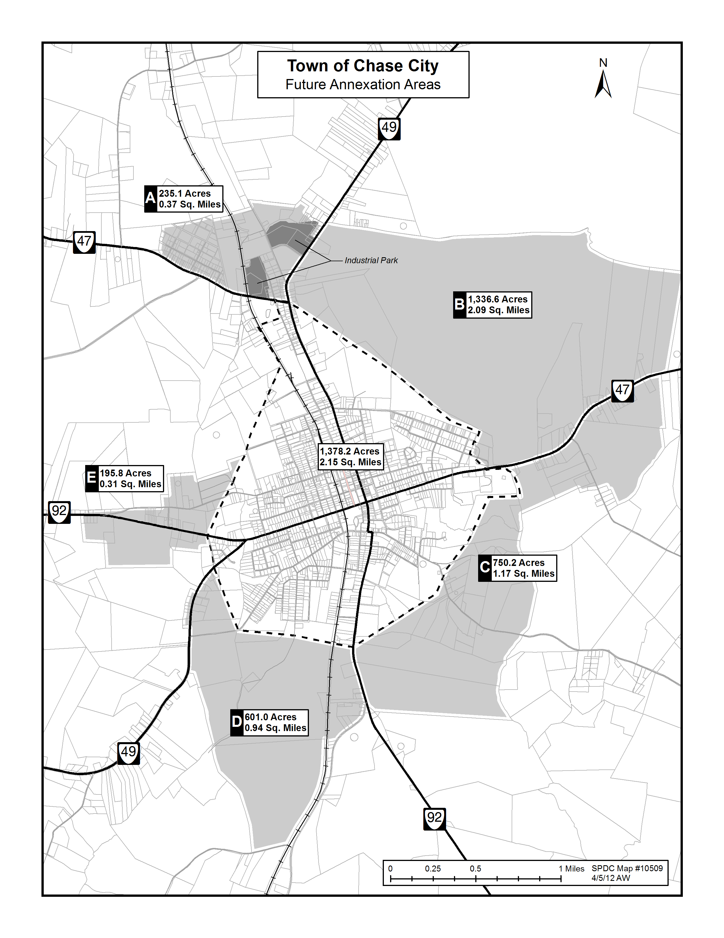

GOALS AND OBJECTIVES STATEMENT
In preparing the Chase City Comprehensive Plan, the following goals and objectives were established to serve as a guide for development.

GENERAL GOAL:
To promote the health, safety, and general welfare for all the citizens of the Town of Chase City, and provide a desirable environment for the present and future generations.

LAND USE:
Promote orderly growth and development based on physical, social, and economic needs, environmental considerations, and the ability of the town’s public facilities and services to support the development.

OBJECTIVES AND STRATEGIES

Land Use Objectives
- Designate and reserve sufficient land for various purposes to meet the needs of projected future population.
- Maintain and expand the tax base by designating specific areas for residential, commercial, and industrial developments.
- Indicate suitable areas for expansion and minimize adverse impacts on surrounding properties.
- Continue to promote improvement and revitalization of the Town’s central business district.
- Establish and maintain interegovernmental cooperation and coordination in land use planning with Mecklenburg County Officials.
- Improve the overall livability of the Town by improving parks and recreational areas including ball fields, bike/walking trails, and other athletic facilities.

LAND USE STRATEGIES
- Petition the County for a boundary adjustment in the areas to allow for future town growth as identified in Future Land Use Plan indicated above.
- The areas to be included are already being served by town utilities.
- Plan areas for development of parks and recreation for youth.

ECONOMY
To improve the quality of life by providing employment opportunities for all by seeking to upgrade income levels in all sectors of the local economy.
Economic Objectives:
- Maintain a balance between residential, businesses, and industrial development thus creating an environment attractive for an orderly growth of the town.
- To actively seek to market the Town’s valuable services available to potential industrial prospects, which include, water and sewer, natural gas, rail service, and hihg-speed broad band. Attempt to piggy-back on other IT development in the county, i.e. Microsoft, nine miles away in Boydton.
- Support the Mecklenburg County School Board in the upgrading of school facilities and the quality of education for our students. Seek diversification of education in order to provide education beneficial to all students, college bound as well as the technical training required in today’s economy.
- Continue to build on the Downtown revitalization by working to attract new businesses.
- More actively market the Estes Community Center as the center-piece of economic and educational development.
- Work with the Southside Community College in expanding the courses offered to our citizens. Take advantage of the main Campus at Keysville and their partnership with Longwood College and Old Dominion University.
- Work with the State’s Department of Tourism in promoting the region which includes the McCallum More Gardens and Museum and other attractions, i.e. Prestwood Plantation. Boyd Tavern, etc.
- Actively market the Kerr Lake Reservoir as a valuable asset which attracts large number of visitors each year.
- Create a Brochure inumerating the town’s valuable assets to Industrial prospects.
Economic Strategies
- Meet with the Director of Mecklenburg Department of Economic Development on a regular basis to discuss strategies for the Chase City area.
- Initiate meetings with the County Board of Sypervisors to explore ways to work collaboratively for the benefit of the Towns and the County. The Towns ability to provide services to areas bordering the town should facilitate overall growth to the benefit of the County.
- Seek ways to market the valuable infrastructure of the Town which includes abundant supply of water, redundancy of power, railroad service, and High-speed Broadband access.
- Meet with officials of the Southside Community College to discuss ways to expand the courses offered at the Estes Community Center, including the college’s ability to provide specialized training for growth sectors of industry.
- Promote and encourage the strengthening of our public school system which includes improvement of the school buildings and facilities, as well as improving the level of education to meet the demands of today’s industry and businesses.
- Recognize that the key to meeting growth in all areas, whether retail, housing, or population is dependent on the availability of jobs and this effort must remain the primary objective of the
Town.
- Continue efforts to attract more retail establishments to the Town.
- Town Officials would work to protect the small town atmosphere of the community.
- Town Officials should encourage a mixture of services which include retail, business, government, professional, financial, and other appropriate services.
- Town Officials should work with local businesses to help retain existing business and promote their expansion.

HOUSING
Maximize the opportunity for a diverse range of standard residential housing to serve the varying housing needs of the existing and future population.
Housing Objectives:
- Allocate proper areas for desirable future low, medium and high-density residential development.
- Provide areas for the construction of publicly assisted-living housing to meet the needs of low-to-moderate income individuals and families.
- To insure that all town residents are afforded safe and sanitary housing.
- To identify and correct housing deficiencies and need to bring all town housing up to minimum acceptable standards.
- Encourage adaptive reuse of existing structures where areas are in transition.

Housing Strategies:
- Review Zoning Ordinance and revise to achieve conformity with the Comprehensive Plan.
- Enforce the Zoning Ordinance.
- Demolish abandoned and dilapidated buildings through enforcement of property maintenance ordinances.
- Town Officials should continue to pursue avenues of financial assistance to develop and implement a comprehensive improvement program for substantial residential structures. The Town should seek available Community Development Block Grants (CDBG) to upgrade these properties.

COMMUNITY FACILITIES:
To improve all community facilities and public services, to accommodate future expansion and existing needs.

Public Safety Objectives
- Increase public safety
- Eliminate crime and drugs
- Maintain and support emergency services
- Cooperate and support local Healthcare Services
Public Safety Strategies
- Provide support to Town Police Department with adequate facilities, training, equipment, and manpower.
- Encourage cooperations between the Police Department and County, State, and Federal law enforcement agencies and their programs.
- Encourage and support the healthcare sector in the delivery of services to the area.
- Support the Volunteer Fire Department and Rescue Squad in their efforts to provide Emergency Services to the Town and area.
- Support the Southside Drug Task Force.
- Town Officials should work with the Police Department, Volunteer Fire Department, and Rescue Squad to ensure that all residents continue to receive quality police, fire, and rescue services.

Recreation & Cultural Amenities Objectives:
l. Provide more recreational activities to area residences of all ages.
2. Town Officials should promote activities at MacCallum More Museum and Gardens, the Estes Community Center, Main Street Pavilion, South Central Fair Grounds, Mecklenburg Country Club, Chase City Fire Deparment Training grounds, the Chase City Community Park, and the Robert E. Lee Auditorium.
3. Explore the possibility of reopening the Mecca Theater in the downtown.
4. Actively seek ways to support the MacCallum More Museum. 5. Encourage the utilization of the Robert E. Lee Auditorium.

Downtown Revitalization Objectives:
- Promote and support efforts to bring more businesses and patrons to downtown.
- Continue efforts to reduce crime.
- Actively encourage and involve citizens participation.

Downtown Revitalization Strategies
- Encourage the re-opening the theater.
- Reduce the empty the vacant stores by placing attractive displays in the windows. Enlist local artists and clubs to participate in this effort by identifying stores.
- Encourage businesses to install adequate lighting in their parking lots.
Infrastructure – Water and Sewer Objectives
1.Upgrade and improve the Town’s public facilities where necessary to meet the needs of new development.
2. Need major improvements and upgrades to Town’s wastewater treatment plant, sewer pumping station, and Town sewer lines.
3. Complete connection to the Roanoke River Service Authority.
4. Review thoroughly all service lines and systems for improvement and/or extension.
5. Town Officials should build a capitol improvement fund in order to be prepared when equipment must be replaced.

TRANSPORTATION:
Provide a transportation system of thoroughfares that serves routing and access demands and minimizes travel costs, time,and adverse social and environmental impacts.
To provide a safe efficient transportation network that will accommodate future expansion and existing needs and that will encourage economic development opportunities.
Transportation Objectives:
- Improve the thoroughfare system to provide for more efficient and direct travel.
- Continue efforts with VDOT to secure a major upgrade of Highway 92 from Chase City to Boydton which allows access to major highways ( I-85 and Hwy 58 ) in the area.
- Encourage intermodal transportation – study ways to improve shipping efficiency for industry and businesses.
- Identify areas for future streets where access would promote development, i.e. Boundary Adjustment areas.
Transportation Strategies:
- Promote railroad access to town as an asset to industrial and commercial development.
- Create maps to promote tourism and encourage visitation.
- Encourage inclusion of pedestrians and biking facilities In new developments and re-development projects.
- Actively collaborate with the Area Transportation Committee and County Department of Economic Development in promoting the upgrade of Highway 92
- Encourage safe and efficient traffic patterns in the development of commerical and industrial districts.
- Provide adequate off-street parking to meet the needs of the downtown area.
CONSERVATION:
Minimize air, water, and noise pollution and ecological damage through comprehensive planning and control of land uses and environmental impacts.
Conservation Objectives:
l. Buffer land uses from generators of noise and vibration that may interfere with the enjoyment of those uses.
2. Eliminate energy waste where possible without increasing costs, decreasing design qualities or disrupting existing life styles.
3. Enhance the overall appearace of the central business district and the Town in general.

THE COMPREHESIVE PLAN
The Strategy
The 2012 Comprehensive Plan for the Town of Chase City is described in this section. The plan is based upon demographic and economic trends, existing patterns of development, natural and man-made growth determinants, growth policies, goals and objectives, input from citizens, appointed, and elected Town officials, Southside Planning District Commission, and the County Director of Economic Development.
Negative factors:
The Town of Chase City is faced with declining and aging population, loss of jobs, loss of business and sales revenue. Crime and drug problems continue to be a problem both locally and countywide. Although there has been great improvement in the downtown area through the major revitalization project, there still needs to be more done in attracting businesses. One of the major negative factors is the unsightly and poorly maintained residential properties, a problem reinforced by comments in the Survey.
Positive factors:
There have been some important positive changes in the County and the Town within the last few years which should lead to major opportunities in the future. First, and most importantly, is the acessibility of the high-speed broadband network that was discussed earlier, a valuable resource to many potential IT businesses and industries. Secondly, the availability of an unlimited source of water, another valuable resource. Finally, the only rail services in the County, an asset to be marketed.
PLAN ASSUMPTIONS
The following are the major assumptions that were used to develop the Plan. These assumptions were generally derived from the data pesented in the previous sections of this document.
Residential Growth
- The population of the Town will continue it’s gradual decline since the 1960’s of over 3,000 to 2,351 in 2010.
- Typical of most towns in Virginia, there is an increasing need for towns to increase their land areas through Boundary Adjustment due to the scarcity of developable land.
- The need to preserve the quality and unique characteristics of the local neighborhood conservation and preservation.
Commercial Growth
- The need to preserve the quality and unique characteristics of the central business district through storefront renovations and landscaping.
- The need to continue efforts to attract a mixture of retail and business services to the downtown area.
Industrial Growth
- The Town will continue its efforts to attract Industrial development to diversify its existing industrial base.
- The Town will continue to guide future industrial development to the existing park location.
- The Town will continue it’s efforts to expand available land for industrial development throughBoundary Adjustment in areas that are prime industrial locations.
Plan Description
The Comprehensive Plan is not intended to delineate land uses for specific parcels of property, or show exact locations of future thoroughfares or public facilities. The Plan is intended to serve as a development policy guide for decision-makers, both public and private, as a public educational and informational tool. It should not be considered a static document and the Plan should be updated on a regular basis and maintained as a current reflection of the Town’s development needs and goals.
The town’s land-use map, as depicted in at Attachment represents the recommended land-use patterns and thoroughfares. The Official Land-Use Map is maintained in the Town Office and will reflect all changes in zoning to date. These major categories are outlined below.
Residential: Land in this zone is intended to be occupied by any type of housing unit plus additional uses such as schools, parks, and churches that serve the residents of the area. Residential Limited (R-l) is composed of certain quiet low-density residential areas plus certain open areas where similar residential development appears likely to occur. Residential General (R-2 and R-3) zones are comprised of certain medium to high density residential uses, ordinarily located between residential and commercial areas. All areas are designed to stabilize and protect the essential characteristics of the district, to promote, encourage, and to be compatible with the adjoining business area.
Business: Land in this category includes all land and buildings used for retail consumer services and professional activities. Business limited (B-l) primary purpose is to establish and protect the business district that will serve the surrounding residential districts in which traffic and parking congestion is held to a minimum to protect and preserve property values. Business General (B-2) covers that portion of the community intended for the conduct of general business to which the public requires direct and frequent access.
Industrial: Land in this category is intended to be used for manufacturng and warehousing including such accessory uses as rail loading yards, parking, and storage. Industrial Limited (M-1) permits certain industries, which do not in any way, detract from residential or commercial desirablity, to locate in any area adjacent to residential uses. Industrial General (M-2) , the primary purpose of which, is to establish an area where the principal use of land is for heavy commercial and industrial operations, which may create some nuisance.
Plan Implementation
Implementation of the Plan requires coordination of the various activities of persons, associations, and governmental bodies. The Town Council of the Town of Chase City is the primary decision-making body; however, the Town Planning Commission is responsible by Virginia State Code to prepare, review and update, the Plan periodically. The Comprehensive Plan is a legal document and should be followed by the Town Council and Planning Commission in all zoning decisions. In addition, local development organizations and residents must be supportive of the goals and policies as set forth in this document.
It is recommended that the Chase City Town Council follow an implementation process that consists of the following steps:
- Adoption of the Plan
- Adoption of policies that are supportive of the Plan
- Adoption of the programs that are supportive of the Plan
Adoption of the Plan Adoption of the Plan consists of three steps. First, the Plan is presented to the Town Planning Commission for its review and recommendation. Second, the Council reviews the Plan and presents it to the town’s residents at a Public Hearing, according to the requirements as set forth in Section 15.1-431,of the Code of Virginia, 1950, as amended. Upon adoption by the Town Council, the Plan will be forwarded to select regional and state bodies to facilitate a coordinated approach toward plan implementation.
Adoption of Policies: Implementation of the Plan depends upon the adoption of policies that support the Plan’s recommendations. The following policy guidelines are offered to assist the Town in effectuating the Plan.
- Use the Plan to stimulate and guide policy proposals
- Initiate and support the preparation of applications, studies, and analyes which are preliminary to policy formulation and adoption.
- Amend town ordinances and codes to comply with the Plan.
Adoption of Programs: Plan implementation Is dependent upon alterations to exisiting programs where necessary. The following guidelines are presented to assist the Town in program development.
- Use the Plan to stimulate and guide program proposal.
- Incorporate implementation projects into a capital improvements budget and program.
- Evaluate programs according to their effectiveness in meeting Plan objectives.
Recommended Techniques
- A variety of implementation techniques are available; however, the following approaches are recommended as the most feasible for effectuat in the Plan
Training for Plan Commission
- First and foremost, the most important aspect of implementing the Plan is the education of the Planning Commission Members. In order to be effective, they must understand the Principles of Planning and Zoning. This training is available through the Citizens Planning Association of Virginia, now PlanViginia, which conducts a Certification Program as well as an online training course.
Land Use Controls
Plan implementation requires the effective application of the zoning and subdivision ordinances. Existing zoning districts should be reviewed and revised according to the recommended future land use patterns where necessary. Additionally, the existing subdivision ordinance and administrative procedures should be reviewed and revised, where necessary.

Capital Improvements Program (CIP)

A Capital Improvments Program is recommended to be developed, according to the provisions setforth in Section15.1-464, Code of Virginia, 1950, as amended. This scheduling and prioritizing of projects, based on the available sources of financing, is necessary in order to facilitate the implementation of the Town’s goals and objectives.

Zoning Ordinance

The Zoning Ordinance should be revised to insure that it is in compliance with the updated Comprehensive Plan. While the Plan is a guide for the future, setting forth goals and objectives, the Zoning Ordinance is the instrument by which these goals and objectives are accomplished.

Codes and Ordinances

Existing housing and building and related codes should be reviewed to determine regulations that may unduly restrict housing development or are wide redevelopment, and amend such regulations where necessary. In particular, the Town should review ordinances that affect the handling of abandoned and unsightly buildings in an effort to deal with this problem.

Coordination
The Plan cannot be implemented in an effective manner without the cooperation of state, regional, and local agencies whose actions or planning efforts impact on the development in the Town of Chase City. It is recommended that open line communication be
maintained with those agencies and the County in order to facilitate coordinated action. Further, it is recommended that the Town take a proactive role in seeking a collaborative relationship with the County, to the mutual benefit of both.

Citizen Participation

Finally, to be truly effective, the Plan must have the on-going support of the general public. They are stakeholders in the Town, and as such, should be involved in order to be supportive of theTown leadership. It is recommended that a public information program be developed which keeps local residents and businesses aware of important issues, plans, policies, and programs. This is easier said than done, but efforts should be made as it will pay big dividends. The Town Council should hold a Community Meeting , at least once a year, to discuss important issues, challenges and accomplishments, more importantly, to get input from the citizens. In order for Chase City to succeed in their effort to become a truly outstanding town, it must rely on the entire community, the citizens, the organizations, and the businesses.

CONCLUSION

The Town Manager, Town Council, and Planning Commission have been actively involved in the revision process and participated in a number of input sessions. The citizens provided valuable input through the Community Survey. In addition, we have had assistance and input from the Southside PlanningDistrict Commission, the County Economic Director, the County Manager and a number of other sources. This Plan represents the combined efforts of the Community, and as such, it is designed to move Chase City forward in the future.

-----------------------------------------------------------------------------------------------

APPENDICES:

PROPOSED BOUNDARY ADJUSTMENT AREA
TOWN MAP
WATER & SEWER LINES
TOWN ZONING MAP

